Lost and Found: Tracking Unvaccinated Children and the Search for a Weather Signal in Northern Nigeria
MSc in International Health and Tropical Medicine, Nuffield Department of Medicine, University of Oxford
Examination Candidate Number: 1102514
30 July 2026

Table of Contents
Candidate’s Contribution and Declaration 3
Research ethics 3
Statement on the use of artificial intelligence 3
Abstract 5
List of Figures 6
List of Tables 6
I. Background and Literature Review 8
A. The zero-dose problem in Nigeria and the Sahel 8
B. Predictors of zero-dose status and tracing effectiveness 10
C. Weather and health-seeking behaviour 11
D. DATHARM and the MCHTrack programme 12
II. Data and Methods 14
A. MCHTrack data structure 14
B. Geospatial weather data 17
C. Model specification and justification 17
i. The zero-dose and recovery models 18
ii. The weather model 19
D. Diagnostic checks 20
III. Quantitative Results 22
A. Descriptive data overview 22
B. Zero-dose model 23
C. Recovery model 25
i. Main results 25
ii. Strict versus reported recovery 27
D. Weather model 28
i. Descriptive overview 28
ii. Main results 29
IV. Discussion and Synthesis 33
A. What the data can show: reading the zero-dose and recovery findings together 33
B. Why the weather model came back null: reading it against Sindh and Miami 34
C. Fieldwork as contextual grounding 35
D. Closing synthesis: convergence across methods 35
V. Conclusion and Recommendations 37
A. Implications for digital immunisation registries 37
B. What remains unresolved about weather, and why it matters beyond this setting 37
C. Limitations 38
D. Future research directions 39
Appendices 40
Appendix A. Decision log 40
Appendix B. Pipeline description 41
Appendix C. Weather model: negative binomial and log-transformed OLS compared 41
Appendix D. Distributions and diagnostics for the main outcome and predictor variables 42
Appendix E. Ward-level residuals from the zero-dose model 46
Appendix F. Off-network share of recovered defaulters, by ward 49
Appendix G. DATHARM data audit summary 49
References 51

Word count: approximately 9,200 (Chapters I-V main text only; excludes front matter, abstract, references, tables, figures and appendices per exam conventions)

Candidate’s Contribution and Declaration
This dissertation analyses programme data from MCHTrack, a community health worker-based digital immunisation tracking system operated by DATHARM, a Nigerian non-governmental organisation, across Kano and Katsina states in northern Nigeria between August 2024 and March 2026.
I undertook a six-week in-person placement with DATHARM at their offices in Abuja, Nigeria, during which I obtained the primary data and conducted fieldwork. I designed the analytical approach myself: I decided how to define zero-dose status and recovery, which variables to include, which model specification to treat as primary, and how to interpret every result. I built and maintained the analytical pipeline across eight R scripts, provided as supplementary material alongside a link to the project’s GitHub repository and described script by script in Appendix B, with substantial AI assistance in writing, debugging, and refactoring the code itself, described in full in the AI use statement below.
I undertook two site visits to primary healthcare centres in the wider Abuja area for contextual grounding, and held informal conversations with DATHARM staff, including programme coordinators for Kano and Katsina, which informed the qualitative context presented in the discussion. These conversations were informal and observational; I did not apply a structured interview protocol or conduct independent qualitative analysis.
I received the following assistance during this project. Dr Prabin Dahal and Dr Aisha Adamu (primary supervisors), Dr Lucy Harrison, and a geospatial methods advisor provided academic supervision; my supervisors reviewed a complete first draft of the dissertation and gave written feedback. DATHARM’s data manager provided the raw programme data and answered clarifying questions about specific data anomalies I identified during the audit. DATHARM’s Chief Executive Officer, Amina Ahmad, is named as a collaborator on this work and provided programme context and review. A research partner, Ahmed Ismail, conducted a parallel and independently written analysis of delivery mode effectiveness using the same MCHTrack dataset; his analysis does not form part of this dissertation.
I obtained statistical advice from my supervisors during normal supervision meetings. I did not engage specialist statistical consultancy.

Research ethics
This dissertation did not require a separate ethics review. DATHARM already held ethical approval for the MCHTrack programme itself, obtained through the relevant Nigerian regulatory channels as part of its routine public health programming in Kano and Katsina, and my access to its programme data was governed by data use agreements signed with DATHARM. I did not need a separate ethics review of my own for three reasons: local approval for the underlying project was already in place before I began; I had no contact with the beneficiary population at any stage of the research; and I had no access to identifiable data, since DATHARM provided the data to me pseudonymised. My research plan was reviewed as part of the placement proposal process through the MSc IHTM programme before the placement began, and no concerns requiring formal ethics referral were identified at that stage.

Statement on the use of artificial intelligence
I used Claude (Anthropic) throughout both the analysis and writing phases of this project.
During the analysis phase, I used it to help write, debug, and refactor the R scripts behind this dissertation’s pipeline: fixing bugs, restructuring code when supervisors’ feedback required a different model specification, and building the figures and tables.
During the writing phase, I used it for drafting and restructuring prose in response to supervisor comments, for style and consistency editing, and for a systematic citation audit that checked every external source cited in this dissertation against the original text.

Abstract
Background. Community-health-worker digital registries such as DATHARM’s MCHTrack aim to close two gaps in routine immunisation: children never enrolled (zero-dose) and children enrolled but lost to follow-up. Whether a programme’s own records can support the claims made about it is rarely tested directly.
Methods. I analysed MCHTrack records for 71,124 children in Kano and Katsina, Nigeria, August 2024 to March 2026. Ward-fixed-effects logistic regression tested distance, age, and gender against zero-dose status under a primary (operational) and a strict (no vaccine contact) definition, and against tracing recovery under a strict (confirmed) and permissive (self-reported) definition. A negative binomial model tested daily facility visit counts in Kano against rainfall, heat, and vegetation greenness.
Results. Distance predicted little under the primary zero-dose definition (a non-significant 4 per cent increase in odds per kilometre) but an 87 per cent increase under the strict definition, roughly fifteen times the primary coefficient. Age showed a comparable amplification. Both lost almost all predictive power once tracing began; SMS or phone contact was associated with higher recovery odds (55-56 per cent), though the data cannot separate a genuine channel effect from attempt sequencing. Recovery stood at 42.6 per cent under a strict, verifiable definition against 77.2 per cent under a permissive definition the protocol also supports, a gap produced by an unrecorded card-check step. None of the three weather variables showed a significant or consistent effect on visit counts under any properly powered specification.
Conclusion. Programme records like MCHTrack’s can support real findings, distance’s amplification under a strict zero-dose definition, and a recovery-reporting gap wide enough to change how performance is judged, but only once verification limits are made explicit. The null weather result cannot be resolved with fields MCHTrack currently records. Both conclusions apply beyond this programme, to any digital immunisation registry built the same way.

List of Figures
Figure 1.1 | MCHTrack footprint map across Kano and Katsina
Figure 2.1 | A child’s path through MCHTrack
Figure 2.2 | Duplicate record set sizes, by state and table
Figure 2.2b | Monthly facility visit volume, by state
Figure 2.3 | Variance-to-mean ratio of daily facility visit counts, by LGA
Figure 2.4 | Baseline distributions of age, distance, and enrolment timing, by state
Figure 3.1 | Distance and age at registration, by number of vaccine doses recorded
Figure 3.2 | Sample construction waterfall
Figure 3.3 | Zero-dose model coefficients
Figure 3.5 | Tracing outcomes and timing
Figure 3.6 | Recovery model coefficients
Figure 3.7 | Strict versus permissive recovery rate, by state
Figure 3.8 | Daily visit diagnostics, Kano’s Ungogo and Gabasawa LGAs
Figure 3.9 | Weather robustness coefficient plot
Figure D.1 | Age at tracing, by state
Figure D.2 | Correlation among each model’s predictors and outcome
Figure D.3 | Mean monthly rainfall by LGA (CHIRPS)
Figure D.4 | Mean daytime heat by LGA (ERA5/UTCI)
Figure D.5 | Mean vegetation greenness (NDVI) by LGA
Figure E.1 | Ward-level residuals, ranked by magnitude
Figure E.2 | Ward-level residuals, mapped
Figure F.1 | Off-network share of recovered defaulters, by ward

List of Tables
Table 2.1 | Baseline characteristics of enrolled children, by site
Table 2.2 | Key definitions used throughout this thesis
Table 3.1a | Zero-dose model — regression summary
Table 3.1b | Recovery model — regression summary
Table 3.2 | Weather model — main results
Table 3.3 | Weather model — offset and non-linearity robustness
Table 4.1 | This thesis against the two closest registry-based precedents
Table 4.2 | Convergence of quantitative findings and field observation
Table C.1 | Weather model — negative binomial and OLS compared

I. Background and Literature Review

A. The zero-dose problem in Nigeria and the Sahel
A zero-dose (ZD) child has received no dose of a diphtheria-tetanus-pertussis vaccine, the standard indicator of complete exclusion from routine immunisation services. This is different from a child who has started a vaccination schedule and simply fallen behind. Most ZD children have had no other contact with the health system either, so the indicator captures exclusion from primary healthcare more broadly, not only missed vaccines. Gavi and the Bill and Melinda Gates Foundation, the two largest funders of global immunisation policy, have each made halving the number of ZD children by 2030 an explicit target, measured against 2019 levels. This is treated as distinct from their targets for overall coverage (Ryman and Brison, 2024).
An estimated 14.3 million children worldwide received no routine vaccinations in 2024 (WHO/UNICEF, 2025), and sub-Saharan Africa accounts for over half that total (GBD 2023 Vaccine Coverage Collaborators, 2025). Nigeria alone holds roughly 2.1 million ZD children, the highest number of any single country (WHO/UNICEF, 2025). Kano and Katsina, this thesis’s two study states, sit in Nigeria’s far north within the Sahelian belt (Figure 1.1), among the states with the highest recorded ZD burden nationally (NPHCDA, 2022). Kano is the country’s most populous state and sits immediately southeast of Katsina. Nigeria’s administrative structure runs from state level through Local Government Areas (LGAs) down to wards; Section II.C.i sets out the modelling implications of this structure.
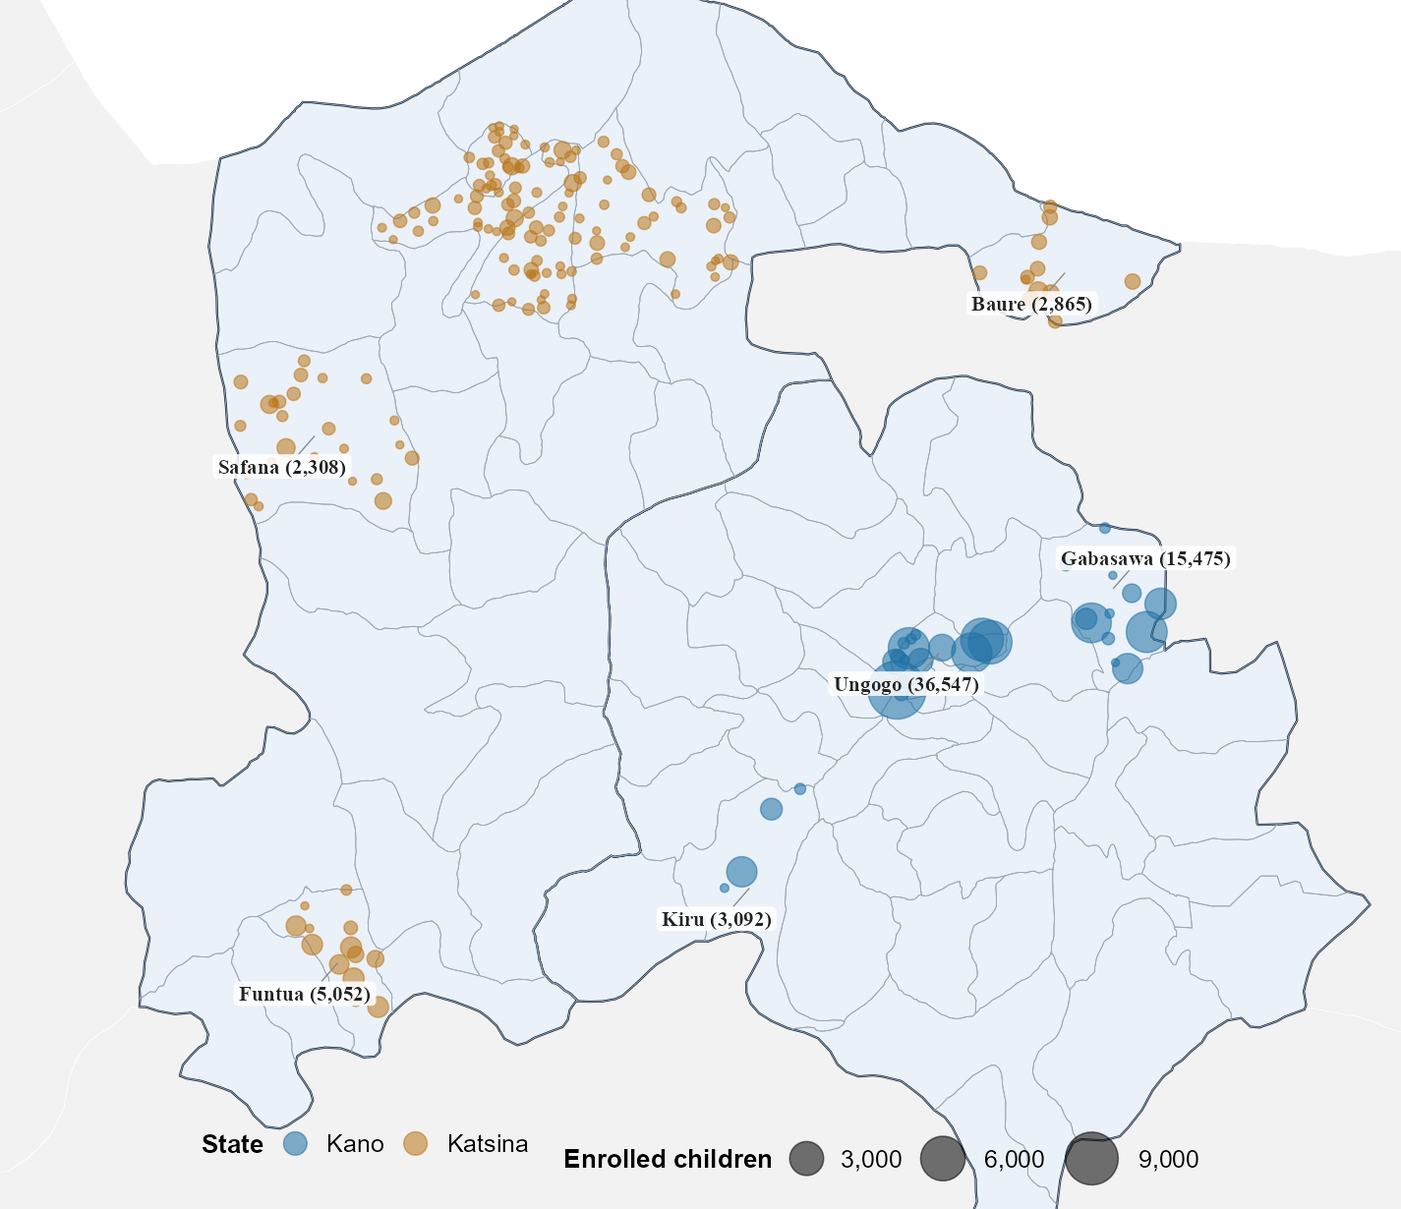
Figure 1.1. MCHTrack’s ward-level footprint across Kano and Katsina
Ward-level map of MCHTrack’s footprint across Kano and Katsina, each point one ward sized by enrolled children. Point positions are randomised within the correct LGA, illustrative of coverage and density only. Labelled LGAs are the top three by enrolment in each state. Administrative boundaries: GADM (2026), version 4.1.
The Sahel, the semi-arid belt stretching from Senegal to Sudan and encompassing Nigeria’s far north, faces compounding pressures. Sabahelzain et al. (2025) synthesise conflict and coverage data across five Sahel countries between 2019 and 2023: drought, desertification and food insecurity on one side, a wave of military takeovers across Burkina Faso, Mali, Chad, Niger and Sudan since 2021 on the other. By 2023, Sudan’s ZD rate reached 43 per cent, Mali’s 22 per cent and Chad’s 16 per cent, likely underestimates given conflict-affected areas surveys struggle to reach and outdated census denominators. A highly mobile population compounds this, since routine data systems struggle to track people who rarely stay in one place long enough to be counted.
Distrust in immunisation programmes has its own history in this region. The 2003–04 boycott of the polio vaccine across northern Nigeria grew out of religious misconceptions about vaccine safety, anti-colonial sentiment toward a foreign-led intervention, and local leaders using it as a political tool against federal authority. Confirmed cases rose from 202 in 2002 to 1,143 by 2006, spreading to roughly a dozen other countries before transmission was controlled (Jegede, 2007; Ghinai et al., 2013). Sabahelzain et al. (2025) note renewed armed-group activity in the same corridor, though their data cannot establish whether this reflects a resurgence of 2003-era distrust or conflict simply making communities harder to reach; the two are not mutually exclusive, since insecurity can deepen suspicion of health workers while also blocking physical access (MacDonald and SAGE Working Group on Vaccine Hesitancy, 2015). Access in Kano and Katsina is better described as inconsistent than closed: the same insecure areas that sometimes see health workers kidnapped still admit vaccinators elsewhere, a more mixed pattern than the largely closed access reported in Pakistan and Afghanistan. This mixed pattern is worth bearing in mind when interpreting the ZD findings that follow.

B. Predictors of zero-dose status and tracing effectiveness
Distance to a health facility is among the most consistently identified predictors of ZD status in sub-Saharan Africa, though the mechanism linking distance to non-vaccination remains a matter of ongoing conceptual work. Guagliardo (2004) frames spatial accessibility not as a single measure but as an interaction between where services are located, how populations are distributed, and what transport options connect the two. This distinction shapes how distance is operationalised in this thesis’s own models (Section II.C.i).
The predictors most consistently tested in the household-survey literature are not the ones MCHTrack’s data can speak to. Farrenkopf et al. (2023), analysing household survey data across 82 low- and middle-income countries, find rural residence, lower household wealth, less maternal education, fewer antenatal visits and home birth all associated with higher odds of zero-dose status; birth order, by contrast, shows little independent association once these other factors are accounted for. MCHTrack collects none of these variables, which is why this review turns instead to distance, the one predictor from this literature that this thesis’s data can test directly. Joseph et al. (2020) approach distance geographically rather than through survey report, modelling travel time to the nearest immunising facility in Kenya. Nationally, three-quarters of the population fall within an hour’s walk under a walking-only scenario, but this masks sharp county-level variation: 62 per cent of counties miss the government’s target of 90 per cent of the population within an hour, and remote counties such as Wajir, Mandera, Turkana and Samburu see far larger shares living beyond that threshold. Travel time beyond an hour is associated with lower immunisation coverage, and beyond two hours the association survives adjustment for wealth, maternal education and residence. Farrenkopf’s household correlates and Joseph’s geographic model test different things, but together they cover both individual circumstance and physical accessibility, the two dimensions between which this thesis’s own distance measure sits. Neither, however, captures how that burden changes over time. Blanford et al. (2012) add this seasonal dimension in Niger, modelling wet- and dry-season cost-distance separately, and find that the wet season substantially lengthens travel times in riverine and low-lying areas. This is a dated estimate, and its magnitude should not be assumed to transfer to Kano and Katsina.
Defaulter tracing and recovery, the second pillar of this thesis, has received comparatively less direct attention in the African literature. A defaulter is a child who started but did not complete their scheduled vaccination course; tracing is following up to complete it. The most directly comparable evidence comes from outside the continent. Using a provincial electronic immunisation registry covering 8.8 million children in Sindh, Pakistan, Miraj et al. (2024) find over ninety per cent of children defaulted on at least one scheduled vaccine. Most, however, were eventually recovered through supplementary outreach. Children in remote rural areas and those born at home, despite higher default rates, were less likely to remain permanently uncovered than children enrolled through fixed facilities. The authors attribute this to outreach disproportionately reaching the most marginalised groups. A rural or home-born child recorded as recovered, however, might equally have been vaccinated elsewhere without the registry linking back to the original record. Miraj et al. (2024) cannot rule this out, and neither can this thesis’s tracing data, a caveat worth carrying forward. This reversal of an otherwise intuitive deprivation-recovery relationship is a useful precedent, though Sindh’s infrastructure is not comparable to Kano and Katsina’s.
These predictors sit within a wider landscape of interventions attempting to close the zero-dose gap. This landscape divides into vertical, campaign-style approaches, intensive, time-limited and disease-specific, and horizontal approaches integrated into routine primary care (Mills, 2005). Where an intervention sits on this spectrum shapes what data it generates. Campaign-style interventions produce coverage snapshots, while a horizontal, technology-enabled programme like MCHTrack produces continuous, individual-level tracking. This is exactly the kind of data the predictor literature would need to test its claims against real programme records rather than survey report.

C. Weather and health-seeking behaviour
Section I.A described drought, food insecurity and a mobile population as part of the wider pressure Sahelian households face. Section I.B described distance as the predictor best supported by the literature, and tracing as a mechanism whose reported effectiveness may not match reality. Weather sits outside both. Whether it independently changes immunisation-seeking behaviour is a separate, testable question, reviewed here.
Two studies test the weather-immunisation link directly, using different data. Nagata et al. (2021) linked Demographic and Health Survey data from 137,379 children across twenty-two sub-Saharan African countries to thirty-year rainfall records, defining drought as annual precipitation below the fifteenth historical percentile. Drought at birth was associated with small but consistent reductions in BCG, DPT and polio vaccination, strongest closest in time to the drought. The authors note that no empirical research had rigorously examined this relationship before their study. The only prior evidence was anecdotal: a measles vaccination rate of 47 per cent recorded during the 1983–85 drought in Timbuktu, Mali (Nagata et al., 2021, citing Carnell and Guyon, 1990), a coincidence in time rather than a tested causal link.
Using over 132 million immunisation records from Sindh’s provincial electronic registry, Siddiqi et al. (2025) find that heat wave days reduced immunisation delivery in Pakistan: enhanced outreach fell most (21.2 per cent), routine outreach substantially (13.6 per cent), and fixed-site delivery was comparatively insulated (5.8 per cent). Rural divisions were also disproportionately affected relative to the provincial capital.
A cross-national household survey linking drought to self-reported coverage, and a high-frequency administrative registry linking heat to delivery records, converge on the same conclusion through different methods. Siddiqi et al.’s registry-based approach is the closer methodological precedent for this thesis, since it tests weather against routine delivery records rather than survey recall. No comparable study taking that approach emerged from this review’s searches, and neither study has been extended to the Sahel.
A related but mechanistically distinct literature addresses climate-induced displacement rather than weather variation. Haque, Parr and Muhidin (2019) find that parents permanently displaced by flooding and riverbank erosion in Bangladesh are markedly less likely to seek care outside the home for a sick child, and far less likely to use a trained provider when they did, despite their children falling ill more often. The authors attribute this to reduced provider access and higher transport costs, rather than to weather variability itself. Displacement and direct weather exposure are different mechanisms, and conflating them would overstate what either literature has shown.
A third, older literature addresses weather and scheduled healthcare attendance outside the immunisation context. Samano et al. (2021) link thirty years of heat index and precipitation data to an HIV clinic registry in Miami. Extreme precipitation increased the relative risk of a missed appointment by thirteen per cent, and extreme heat showed a comparable association. This is useful chiefly as a methodological precedent rather than a substantive one. Its causal mechanism runs the opposite way to this thesis’s question: heat there exacerbates chronic conditions and increases care-seeking, rather than deterring a discretionary preventive visit. Its adult, insured population also bears little resemblance to the paediatric context examined here.
Taken together, these three tiers of evidence leave weather-immunisation linkages sparse, mechanistically inconsistent in what they measure, and untested in the Sahel. This thesis’s weather analysis sits closest to Siddiqi et al.’s registry-based approach, extended to a context none of the studies cover.

D. DATHARM and the MCHTrack programme
Routine immunisation in Nigeria is delivered through weekly fixed-post sessions at health facilities, plus periodic outreach in wards without one, following Federal Ministry of Health and National Primary Health Care Development Agency guidance (FMOH and NPHCDA, 2013). Which channel a caregiver can use depends on the same access barriers described in Section I.A, and outreach is less predictable where insecurity disrupts scheduling. DATHARM, a Nigerian social-technology organisation, built its MCHTrack programme to work within this structure: finding ZD children missed by both channels, and following up those who started but did not complete their schedule.
Community health workers with mobile devices identify unvaccinated children, refer them to facilities, and trace those who default (DATHARM, 2026). Piloted in Katsina in 2019 as a maternal-health tool, MCHTrack later scaled across dozens of wards in the highest-burden LGAs (Gavi, the Vaccine Alliance, 2025). This reflects a broader trend of mobile registries strengthening immunisation systems in low-resource settings. Its routine, high-frequency data, however, remain analytically unexploited in published research.
This dissertation is positioned at the intersection of the three literatures above, though not in equal measure. Distance is a well-established ZD predictor, but one measured through household survey report rather than the routine, high-frequency programme data MCHTrack generates. This thesis tests whether it holds when measured differently. Tracing recovery rates are, as Miraj et al. (2024) show, vulnerable to being read as genuine recovery when they may equally be a data artefact of what a registry can and cannot see. This is exactly the question the second research question below asks of MCHTrack’s own tracing data, rather than assuming the answer. Weather and immunisation-seeking have been linked directly in only two studies worldwide, neither in the Sahel and neither Nigerian. This is a thin evidence base, and the third research question below extends it to a context it has not yet reached. MCHTrack does not close any of these three gaps outright. It offers one dataset against which to test all three at once, and an opportunity to examine how far its own data can be trusted to support the conclusions drawn from it.

Three research questions therefore guide this thesis:
- What individual and geographic characteristics predict zero-dose status among children enrolled in MCHTrack, and how does the choice of zero-dose definition bound what those predictors can show?
- What predicts successful recovery through defaulter tracing, and to what extent do programme records support the recovery rates they report?
- Whether rainfall, heat and vegetation patterns explain any part of the variation in immunisation-seeking behaviour that the first two questions leave unexplained.
These questions share a common thread: each asks not only what the data shows, but how far it can be trusted to show it. The chapter that follows sets out the data and methods used to answer each in turn.

II. Data and Methods
Answering the first two questions requires individual-level records of enrolment, ZD status, and tracing outcomes. Answering the third requires a different kind of outcome, one that varies day to day rather than child to child. This outcome is matched against weather data sourced independently of MCHTrack. This section sets out both data sources and the modelling choices built around what each can and cannot support.

A. MCHTrack data structure
Before a child’s record exists in MCHTrack, vaccination in Kano and Katsina ordinarily follows a simpler path. A caregiver becomes aware a child is due a dose through a community health worker’s (CHW) house-to-house visit, a reminder from an earlier facility encounter, or word of mouth, then travels to a facility or waits for an outreach visit. The dose, once given, is recorded on a paper card kept by the family, the primary vaccination record across most of Nigeria.
MCHTrack sits alongside this process rather than replacing it, and generates four linked datasets (Figure 2.1). CHWs carry tablets and, during house-to-house enumeration, identify children who appear to have missed scheduled doses, entering them as zero-dose in the linelisted dataset at enrolment. Linelisted records every age-eligible child a CHW enumerates, not only those flagged zero-dose. This is what makes it possible to model zero-dose status as an outcome at all: the analysis needs both zero-dose and vaccinated children to compare. A subset of flagged children are confirmed and logged in the identified zero-dose dataset, with the stated reason for non-vaccination where available. Once flagged, a referral is generated, and any subsequent vaccination encounter is logged in facility visits. If a flagged child does not appear there within an expected window, a tracing attempt is logged in defaulter tracing, recording contact method, date, and outcome.
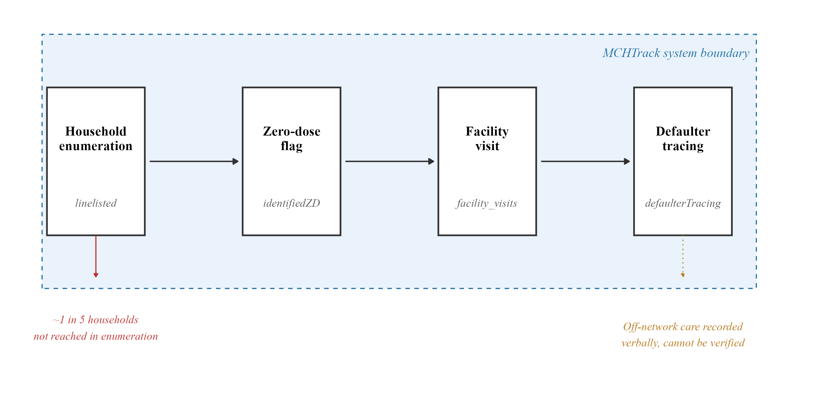
Figure 2.1. MCHTrack data pipeline and its structural blind spots
Flow diagram of a child’s path through MCHTrack: enrolment in the linelisted table, confirmation in the identified zero-dose table, any subsequent encounter in facility visits, and a tracing attempt in defaulter tracing if none appears. Two points fall outside this system boundary and are marked on the diagram: households never reached during enumeration, and vaccination delivered off-network and reported only verbally.
Table 2.1. Baseline characteristics of enrolled children, by site
Site | N | Female (%) | Age at registration, months | Distance to facility, km | Enrolment window | Zero-dose (%)
Kano | 55,678 | 50.7% | 2.2 (0.5–9) | 0.25 (0.05–0.71) | Jul 2024–May 2026 | 8.6%
Katsina | 15,446 | 53.1% | 12 (4–32) | 0.4 (0.21–0.63) | Mar 2024–Sep 2025 | 21.7%
Overall | 71,124 | 51.2% | 3.8 (0.7–12) | 0.29 (0.06–0.69) | Mar 2024–May 2026 | 11.4%
Median distance to nearest health facility, median age at registration, and number of enrolled children, by state and overall; interquartile ranges in parentheses.
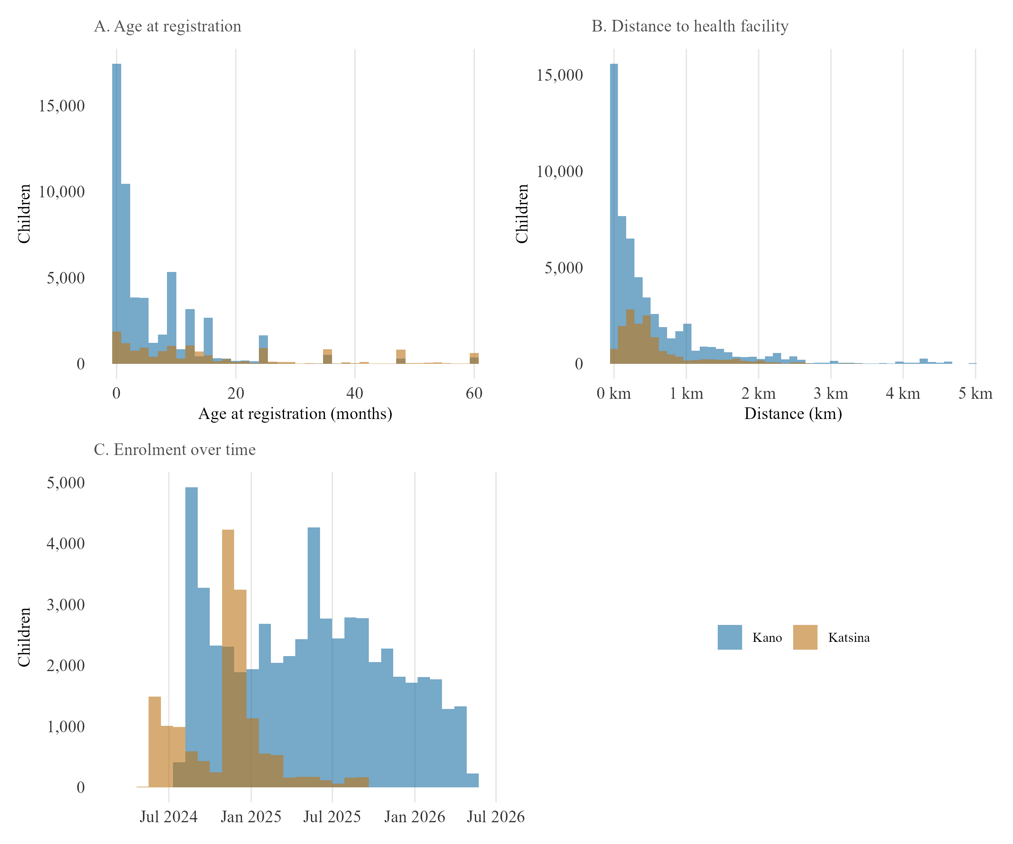
Figure 2.4. Baseline characteristics by site — age, distance, and enrolment timing
Panel A: distribution of age at registration, by state. Panel B: distribution of distance to nearest health facility, by state. Panel C: enrolment volume over time, by state.
Table 2.1 and Figure 2.4 summarise the primary analytic sample’s baseline characteristics by state. Four properties of this system bear on what follows.
First, undercounting during household enumeration is a documented problem in Nigerian immunisation planning. DATHARM’s Kano coordinator estimates roughly one in five households are missed during enumeration rounds, and no field records this gap. Every ZD count here is therefore a count of children found, not children who exist.
Second, there are likely problems with record reliability. Katsina’s facility visits table showed 38.9 per cent duplicate records and its linelisted table 22.1 per cent, both traced to a device handover causing records to sync more than once. Affected rows were removed before analysis, so Katsina results rest on a smaller, corrected sample than the raw export suggests. Appendix G summarises this and the other data-quality issues identified during the audit of DATHARM’s raw exports.
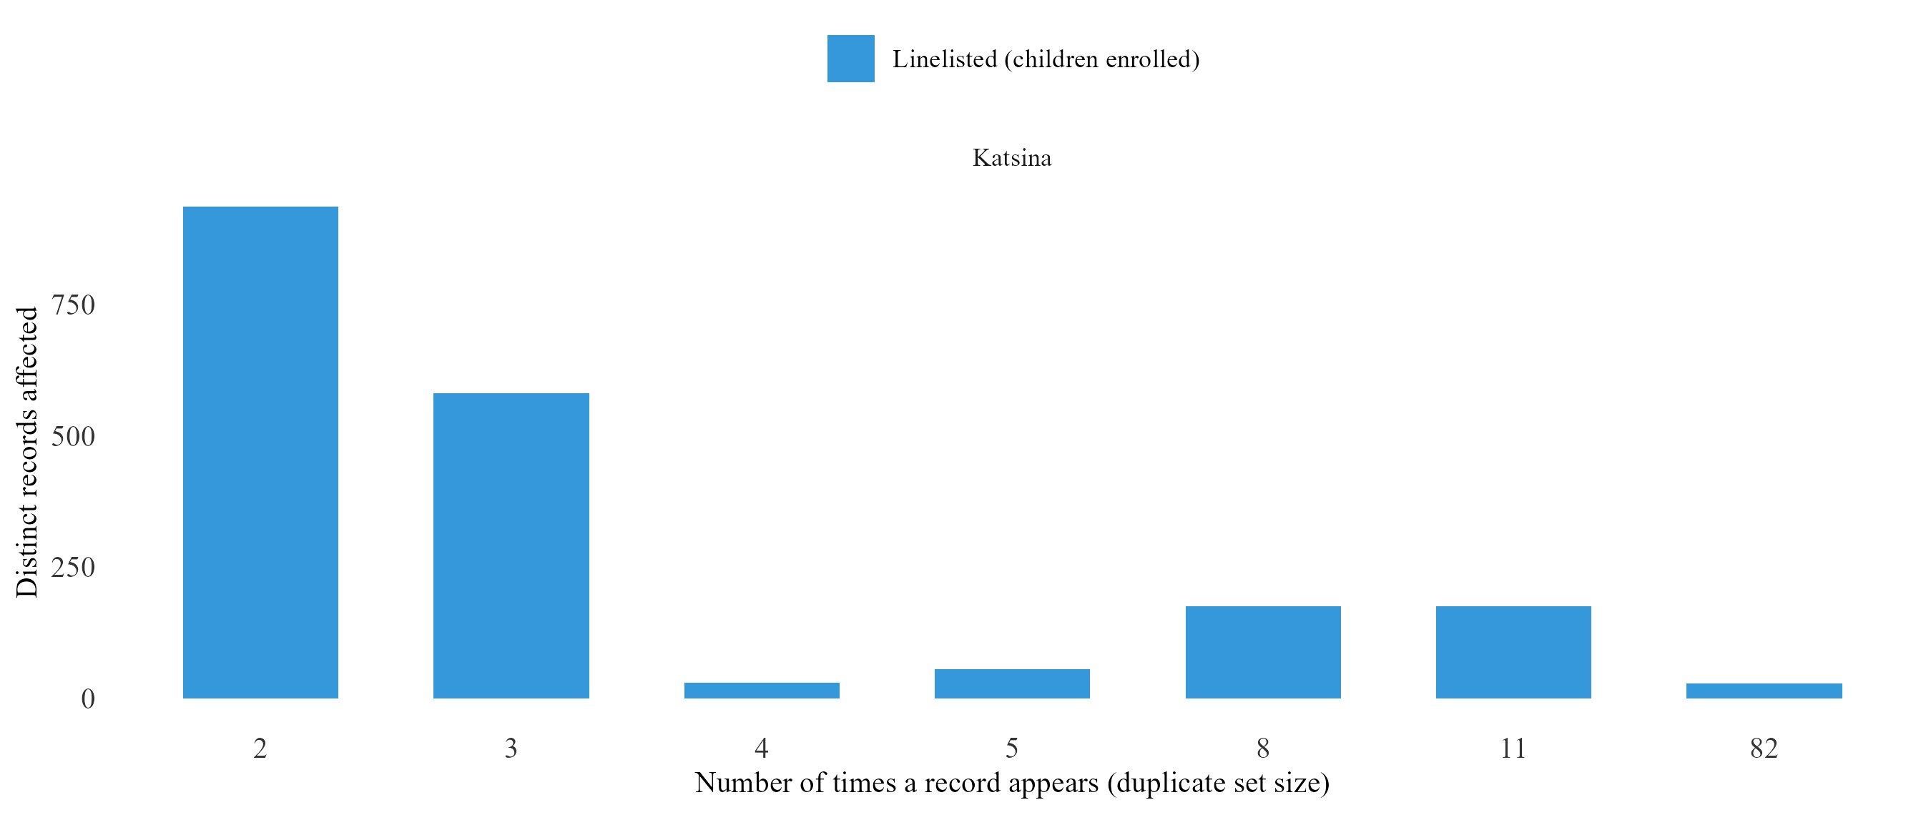
Figure 2.2. Duplicate record set sizes by state and MCHTrack table
Number of distinct records affected by duplication, by duplicate-set size (number of times a record was captured), state and table, based on the snapshot captured immediately before deduplication at import.
Third, recovery is subject to a similar limitation. DATHARM’s protocol requires a CHW to physically check a vaccination card before recording recovery, but the tracing table records only that a card was checked, not what it showed or when, and a check simply closes the case. This thesis calls this the verification gap: a record can confirm that a check happened without confirming what it found. The verification gap is why a strict recovery definition and a permissive one including self-reported off-network care diverge as widely as they do (Section III).
Fourth, geography introduces a further limitation. A small number of LGAs, Rimi among them, showed signs of backfilled data entered retrospectively, so I excluded Rimi from every primary analysis. Katsina’s data quality also degrades further after September 2025, a decline the correction applied above cannot fully offset. The first two research questions still draw on both states, since duplication was fixed at source. The third question, on weather, uses Kano alone, since a daily count outcome is far more sensitive to residual noise than a binary one. Appendix A records this and the other analytical decisions behind this dissertation’s methodology, alongside the alternative each one ruled out.
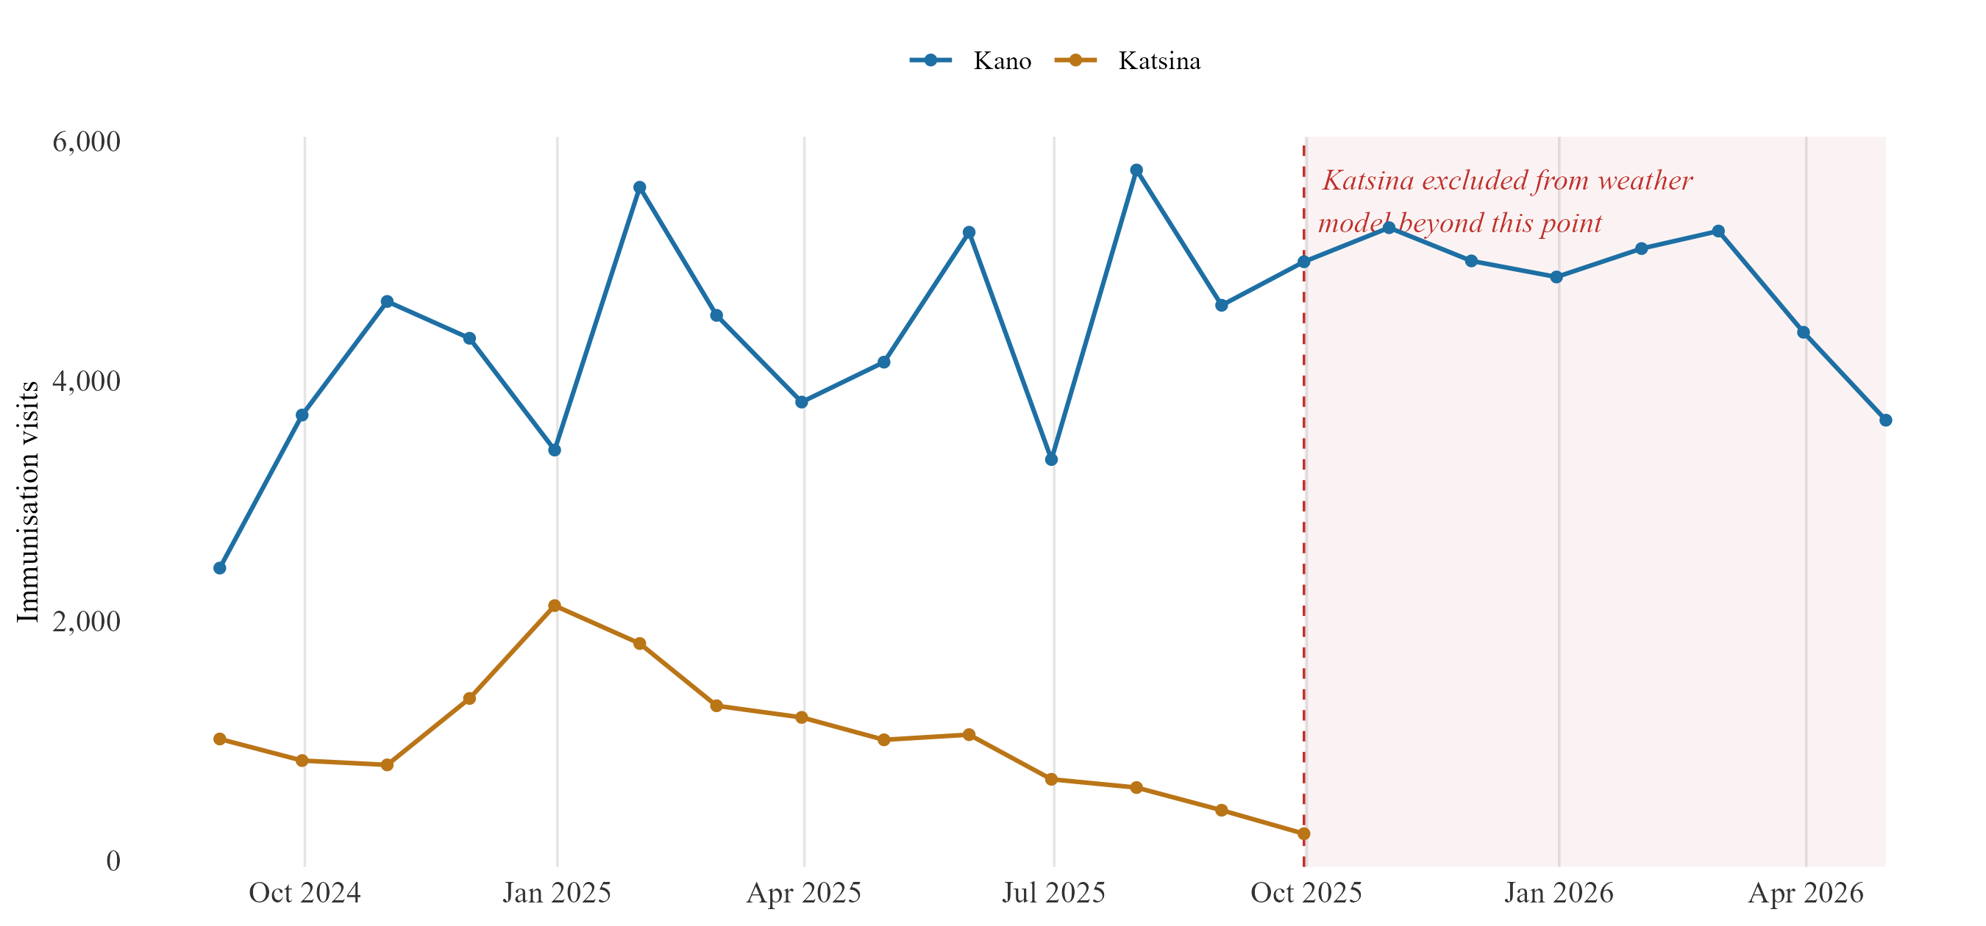
Figure 2.2b. Data reliability by state — monthly immunisation visit volume
Monthly facility visit volume by state, with the point beyond which Katsina is excluded from the weather model marked on the chart.

B. Geospatial weather data
Weather data is not generated by MCHTrack and is joined to it separately, matched at LGA and day level, the finest resolution at which both sides of the join are reliably available. Daily rainfall is drawn from CHIRPS (Climate Hazards group Infrared Precipitation with Station data), maintained by the Climate Hazards Center at UC Santa Barbara. It is gridded at roughly 5 kilometres and available daily back to 1981 (Funk et al., 2015; World Food Programme, 2026a). Heat exposure is drawn from ERA5-HEAT, a reanalysis-derived thermal comfort product maintained by the Copernicus Climate Change Service. It is aggregated here to daily maximum and mean values expressed as UTCI (Universal Thermal Climate Index), a measure of perceived heat stress rather than raw air temperature (Di Napoli et al., 2021; Copernicus Climate Change Service, 2026). A vegetation greenness index, NDVI (Normalised Difference Vegetation Index), is derived from dekadal MODIS satellite composites. It is included here as a proxy for agricultural conditions and indirect economic pressure on households (World Food Programme, 2026b).
All three were selected against the same criteria: daily or near-daily resolution, full coverage of Kano and Katsina across the study period, and a record of prior use in comparable health research. CHIRPS and ERA5-derived heat indices meet this bar most directly, both used in the two studies identified as the closest precedent (Section I.C). NDVI is more exploratory, included on the strength of an established link between vegetation conditions and household agricultural income in Sahelian settings rather than any direct precedent in the immunisation literature.

C. Model specification and justification
The data limitations above bear directly on how each research question is approached. This section sets out two model types: a shared logistic regression framework for the first two questions, and a separate count-based model for the third.

i. The zero-dose and recovery models
The first research question, what predicts zero-dose status, and the second, what predicts successful recovery through defaulter tracing, are both approached using logistic regression with ward-level fixed effects. Throughout this thesis, the model addressing the first question is called the zero-dose model, and the model addressing the second is called the recovery model.
Three terms recur throughout the results that follow and are collected in Table 2.2 rather than left implicit.
Table 2.2. Key definitions used throughout this thesis
Term | Definition
Zero-dose status, primary definition | A child missing the first scheduled dose specifically, based on MCHTrack’s operational flag.
Zero-dose status, strict definition | No vaccine contact of any kind recorded in the system.
Recovery, strict definition | A confirmed in-network vaccination record.
Recovery, permissive definition | Also counts self-reported off-network care, confirmed only by an unverified card check.
Tracing method (channel) | How a defaulter-tracing attempt was made: SMS/phone contact, or an in-person home visit.
Defaulter / defaulter tracing | A child who missed a scheduled dose and is followed up to restore contact.
“Defaulter” frames a missed dose as the family’s lapse rather than the system’s, a framing this thesis does not endorse. The term is retained because it is both DATHARM’s own operational term and the term used throughout the wider literature this thesis engages with, and substituting a different term here would obscure rather than clarify the comparison.
Both outcomes are binary, so logistic regression is used throughout. Models are estimated in R, using the feglm() function from the fixest package (Bergé, 2018), which absorbs fixed effects computationally, a practical necessity given the number of wards involved.
Nigeria’s administrative structure runs from federal level through 36 states, then LGAs, then wards, the smallest unit at which MCHTrack records a child’s location. Kano State alone contains 44 LGAs and several hundred wards, finer than most household surveys can support. Both models apply fixed effects at this ward level, since wards differ systematically in baseline zero-dose rates for reasons unrelated to any individual predictor, including how thoroughly each has been enumerated. Without accounting for this, a model risks crediting ward-level differences to distance, the likeliest correlated predictor given how unevenly facilities are distributed.
Even so, the enumeration gap leaves one distinction fixed effects cannot resolve. A ward with an unusually high zero-dose count may have more unvaccinated children, or may simply have been covered by a more diligent health worker who found more of the children who were always there. The model cannot separate these two explanations from the records alone. Any ward singled out this way is a candidate for field verification, not a confirmed estimate of relative need (Section V).
The zero-dose model is specified as Equation 1:
$$\text{logit}\left(P\left(\text{ZD}=1\right)\right)=β_{0}+β_{1}⋅\text{Distance}+β_{2}⋅\text{Age}+β_{3}⋅\text{Gender}+α\left(\text{ward}\right), \left(1\right)$$
where Distance is measured in kilometres to the nearest health facility, Age in months at registration, Gender is coded female relative to a male reference, and ward denotes one of several hundred wards across Kano and Katsina. Distance and age both have strong prior support as predictors of ZD status across sub-Saharan Africa (Section I.B). Gender does not, and is included as a standard demographic control.
The recovery model is specified as Equation 2:
$$\text{logit}\left(P\left(\text{Recovered}=1\right)\right)=β_{0}+β_{1}⋅\text{Method}+β_{2}⋅\text{Distance}+$$
$$β_{3}⋅\text{Age}+β_{4}⋅\text{DaysSinceVisit}+α\left(\text{ward}\right), \left(2\right)$$
where Method is coded SMS or phone contact relative to a home-visit reference, Distance and Age are defined as above, and DaysSinceVisit is the number of days between a child’s last recorded facility visit and the tracing attempt.
Of these, only distance carries comparable prior support. Evidence on recovery specifically is thin, with Miraj et al. (2024) the only direct precedent (Section I.B). Distance and age are included because the verification gap described in Section II.A gives reason to expect distance might matter differently once tracing is underway. A child far from a facility may be harder to enumerate, but recovery can proceed by phone or SMS without travel. Time since the last recorded visit has no precedent in this literature, one example of a wider gap in MCHTrack’s fields (Section V).

ii. The weather model
The third question, whether weather explains variation the first two models leave unexplained, requires a different outcome. ZD status changes rarely for any child, while daily facility visit counts by LGA change constantly. This makes daily visit counts the right outcome for testing whether short-term weather predicts care-seeking, independent of any child’s fixed characteristics. Daily counts are heavily overdispersed (Section II.D), so the primary specification models visits as a negative binomial count rather than transforming them to a continuous scale, shown as Equation 3:
$$\text{Visits}∼\text{NegBin}\left(μ\right), ln\left(μ\right)=β_{0}+β_{1}⋅\text{Rainfall}+β_{2}⋅\text{Heat}+$$
$$β_{3}⋅\text{NDVI}+δ\left(\text{LGA}\right)+γ\left(\text{day-of-week}\right)+θ\left(\text{month-year}\right). \left(3\right)$$
Here, Rainfall, Heat and NDVI are the daily LGA-level weather measures described in Section II.B, and fixed effects are included for LGA, day of week, and month-year. This is estimated in R, using the fenegbin() function from the same fixest package. A log-transformed OLS specification is retained throughout as a comparison, reported in full in Appendix C and summarised alongside the primary NB results in Section III.D. The plus-one term this version requires distorts the relationship most on the low-count days most exposed to the gaps described in Section II.A, one reason NB is treated as primary here.
Two robustness checks apply to both specifications. The first is an offset term based on each LGA’s enrolled child population, which converts the outcome to a rate relative to that population, so that more enrolled children are not mechanically credited with more visits regardless of weather. The second replaces the linear weather term with a spline, allowing the relationship to bend rather than assuming a straight line. Section III.D reports both checks against the primary specification.
Six specifications of Equation 3 are reported in Chapter III, labelled W1 through W6 in Table 3.2. W1 and W2 use monthly and daily precipitation anomalies. W3 and W4 use a binary extreme-heat threshold and a continuous UTCI measure. W5 and W6 use two NDVI specifications, a seasonal level and a within-baseline anomaly. The offset and spline robustness checks above are applied across all six and reported together in Table 3.3. Naming these labels here means Chapter III can refer back to a specific specification without re-explaining what each one is.
Siddiqi et al. (2025) and Samano et al. (2021) offer the closest precedent for this approach (Section I.C). Neither comparator registry carries the enumeration gap or the verification gap described in Section II.A, so a null or positive result here cannot be read on the same footing as either one. Section IV returns to this point.
The distributions of the main outcome and predictor variables were examined before any model was fitted, to confirm no variable behaves in a way that would undermine either specification. Distributions showing no notable pattern are reported in Appendix D rather than the main text.

D. Diagnostic checks
This diagnostic applies specifically to the weather model, since it is the only one of the three with a count rather than binary outcome. Visit data shaped by discrete events such as market days and religious holiday periods typically shows variance well above the mean. The variance-to-mean ratio in Figure 2.3 confirms this pattern. Given this mismatch, a Poisson model is not appropriate, motivating the negative binomial specification introduced in Section II.C.ii.
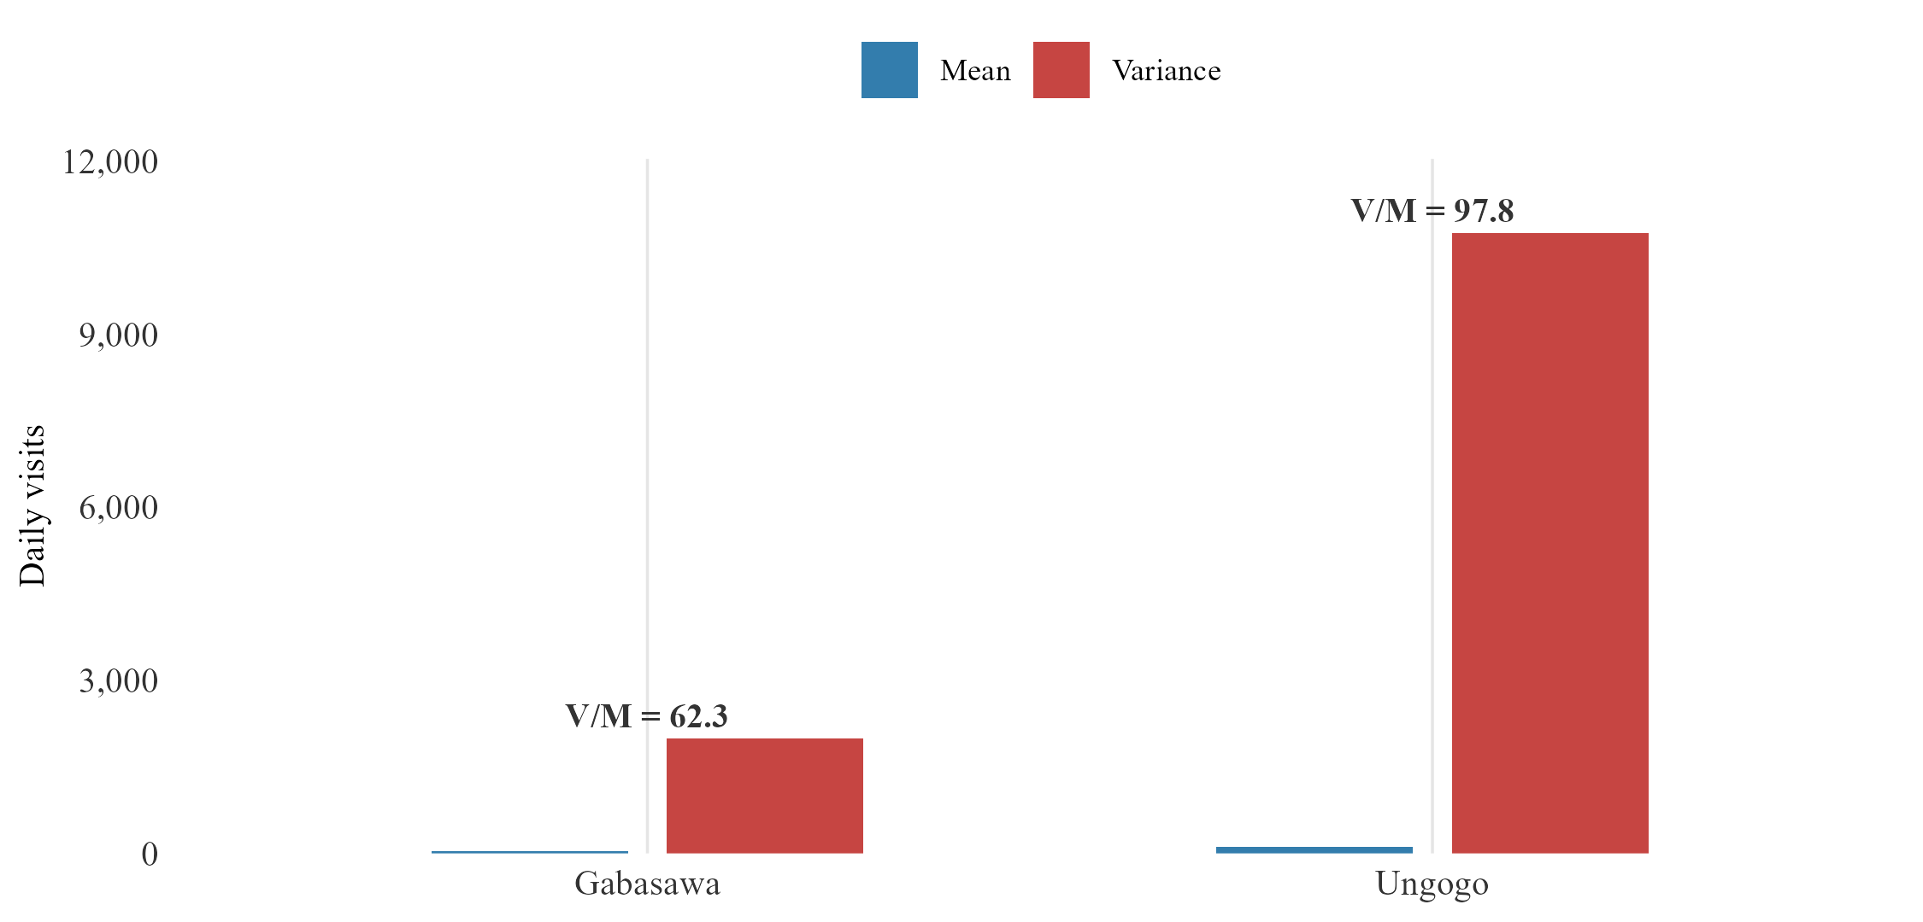
Figure 2.3. Overdispersion in daily facility visit counts
Variance-to-mean ratio of daily facility visit counts, by LGA. A ratio of one would indicate no overdispersion; every LGA examined here falls above that line.

III. Quantitative Results

A. Descriptive data overview
The primary analytic sample for the zero-dose model comprises 71,124 children across Kano and Katsina (Figure 3.2), built from 101,312 raw linelisted rows by removing 7,744 duplicate rows at import, 19,860 non-child records, 831 rows with missing or implausible distance values, 163 rows with an implausible derived age in either direction (below zero or above 180 months, excluded as data-entry errors per the Decision Log, Appendix A), and 1,590 rows in Rimi LGA for the backfill issue described in Section II.A. The regression itself, reported in Table 3.1a, runs on 70,314 children, after a further 810 rows are excluded for singleton ward-fixed-effect groups or residual covariate missingness not itemised in the waterfall. This narrowing is not necessarily random. A household enumerated incompletely is also likely one whose distance or location data was recorded incompletely, biasing the analytic sample toward more thoroughly documented cases, a limitation carried into every zero-dose estimate that follows.
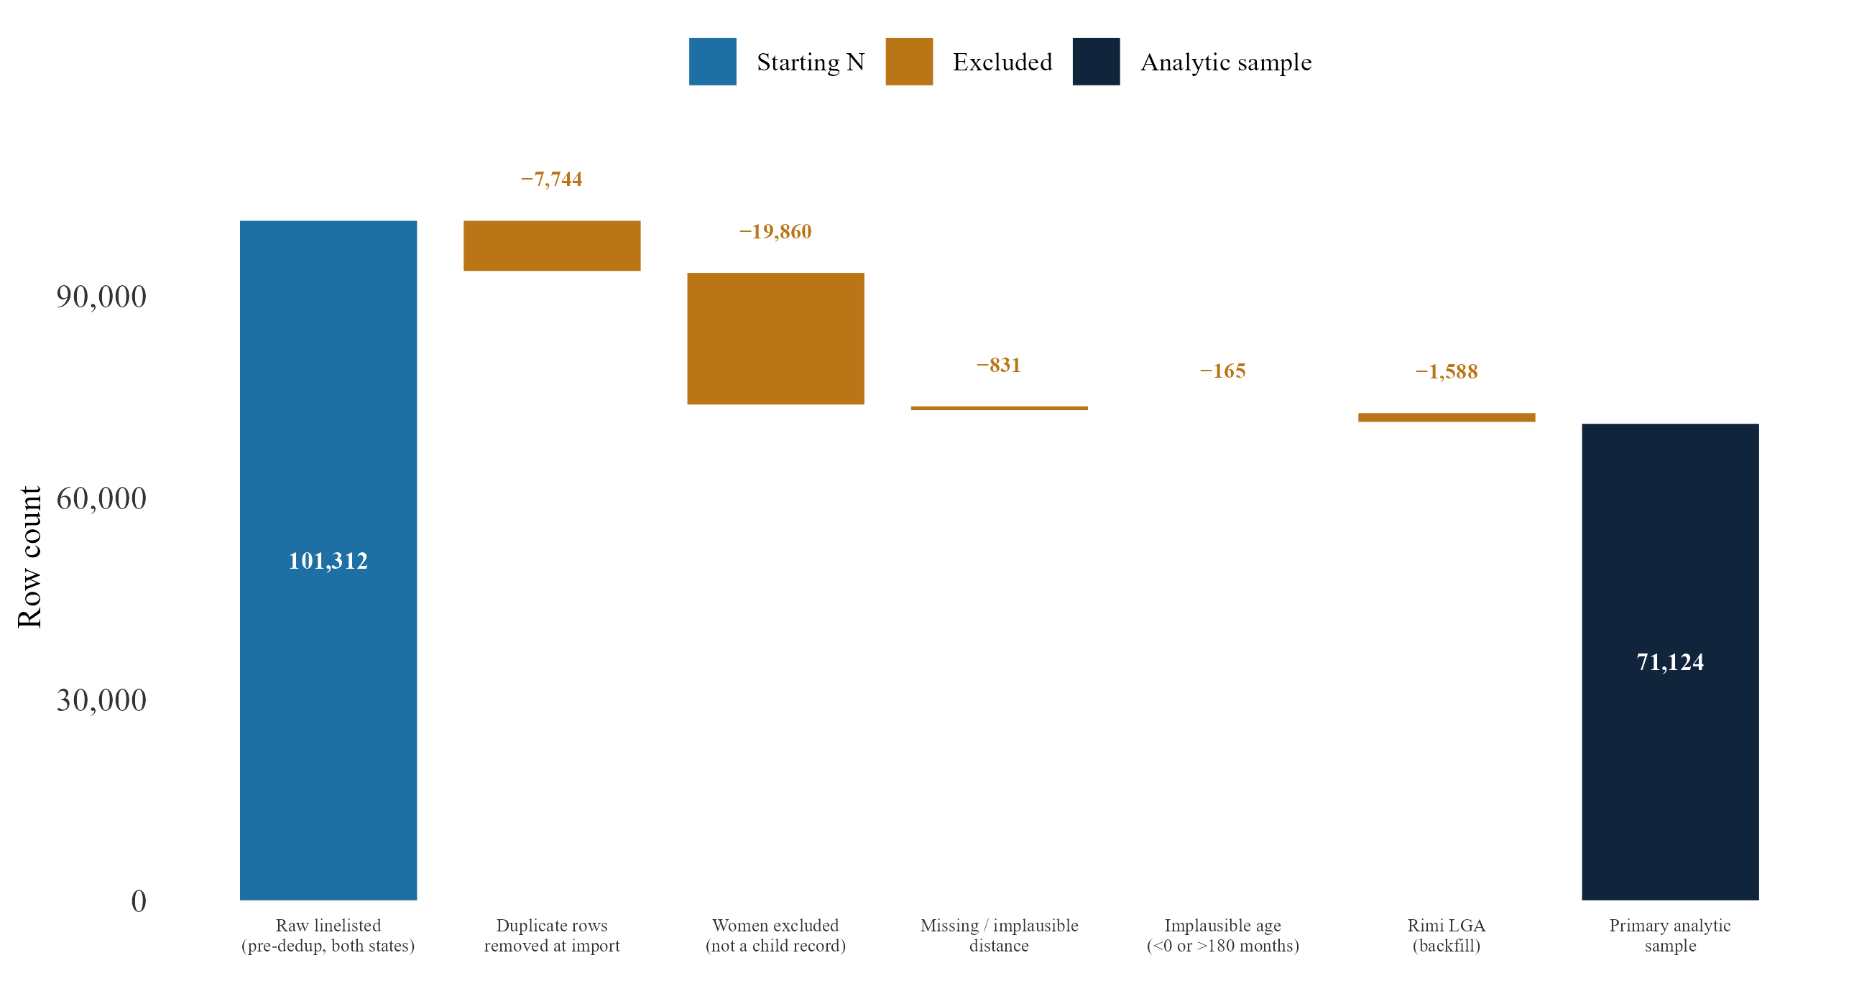
Figure 3.2. Analytic sample construction — zero-dose model
Waterfall of exclusion steps from the raw linelisted rows to the 71,124-child primary analytic sample, with the further reduction to the 70,314-child regression sample described in the text above. 33 Null-LGA rows are not yet excluded from the primary sample shown here. If applied, the primary sample would fall to approximately 71,091.
Distance to the nearest health facility is heavily right-skewed across this sample (Figure 3.1). Zero-dose children sit further along that tail than vaccinated children do, though the two distributions overlap substantially, and a child can live close to a facility and still be missed. The recovery model draws on a separate sample of 38,913 tracing attempts, of which 16,132 can be matched to a prior facility visit date and so carry a usable lag-time value. The weather model’s outcome, daily facility visit counts by LGA, is described separately in Section III.D, since its heavy zero-inflation and marked overdispersion motivate the modelling choice discussed in Section II.D.

B. Zero-dose model
Research question one asks which individual and geographic characteristics predict zero-dose status, and how the choice of definition shapes what those predictors can reveal.
Age at registration is a significant predictor of zero-dose status under both definitions, and, like distance, amplifies sharply under the strict one. Each additional year of age is associated with roughly a 3.7 per cent increase in the odds of zero-dose status under the primary definition (95% CI on the monthly coefficient [0.001, 0.005]). This is consistent with children enrolled later in MCHTrack’s coverage period mechanically having had more time to fall behind schedule before anyone notices. Under the strict definition, the odds roughly double (95% CI [0.045, 0.077]), an amplification of similar shape to distance’s, though this thesis’s data cannot say whether the two share a common mechanism. The pattern is visible in concrete terms too: children with no vaccine dose recorded anywhere in MCHTrack, the strict zero-dose group, register at a median age of 11.0 months and a median distance of 0.49 km from their nearest facility, against 9.0 months and 0.20 km for children with one to four recorded doses, and 1.2 months and 0.16 km for those with five or more (Figure 3.1). There was no significant association between gender and zero-dose status under the primary definition, a non-significant 4 per cent increase in the odds (β = 0.039, 95% CI [−0.022, 0.100], crossing zero), and the coefficient stayed similarly small and non-significant under the strict and Rimi-inclusive specifications alike.
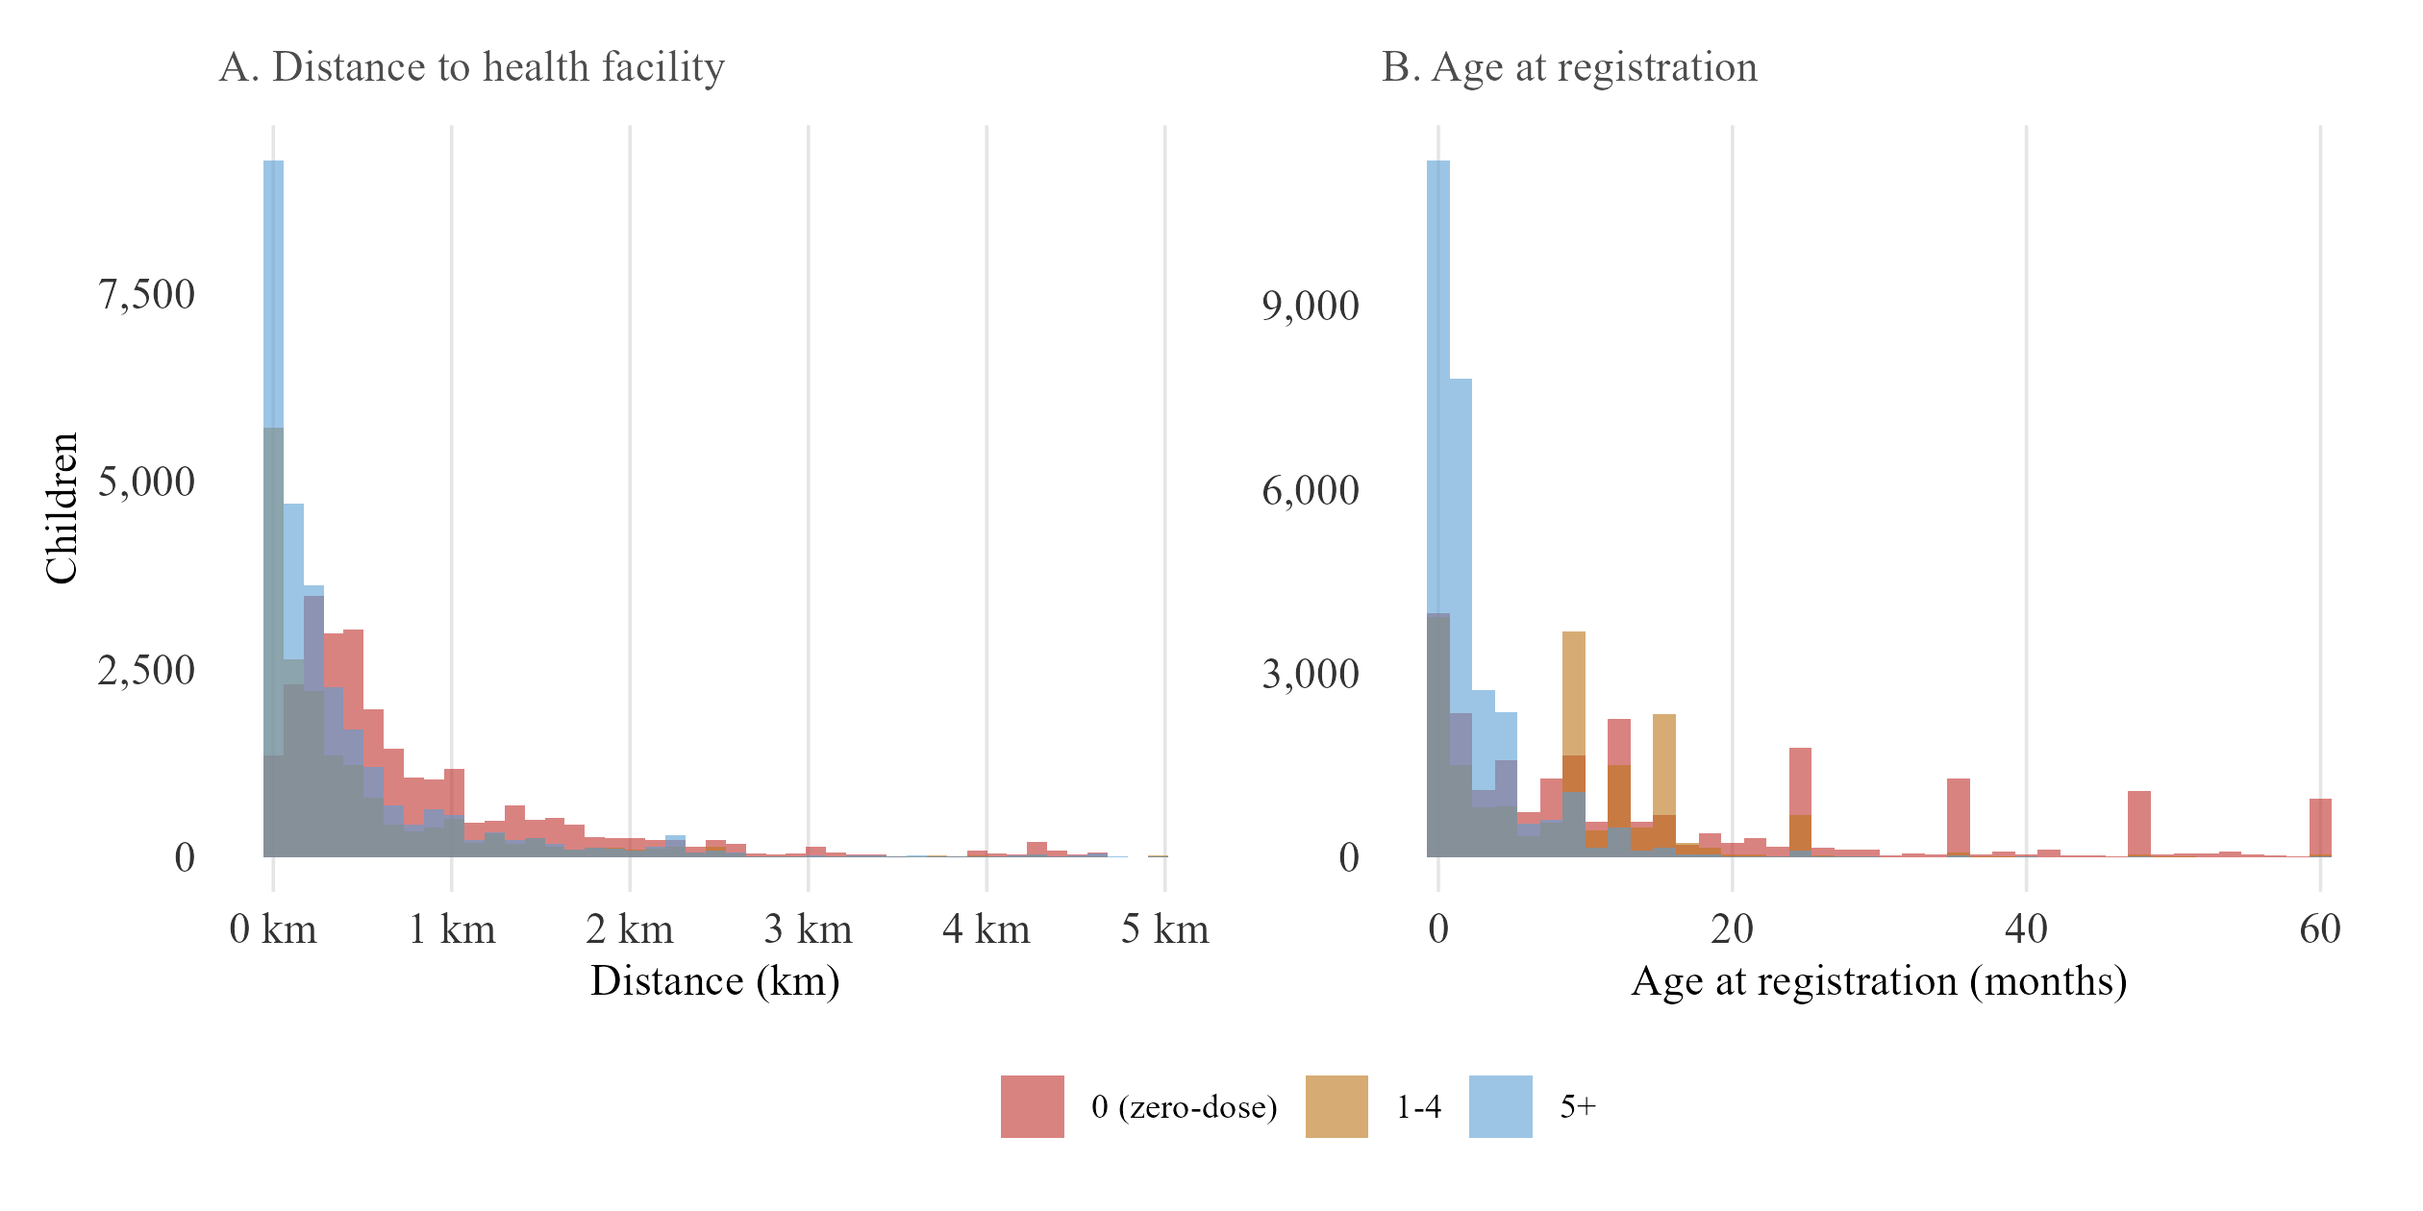
Figure 3.1. Predictor distributions by recorded dose count
Panel A: distribution of distance to the nearest health facility (capped at 5 km), by number of vaccine doses recorded (0, corresponding to the strict zero-dose definition; 1-4; 5+). Panel B: distribution of age at registration (capped at 60 months), by the same grouping. Median distance falls from 0.49 km among children with no recorded dose to 0.16 km among those with five or more; median age falls from 11.0 months to 1.2 months over the same range.
Distance to the nearest health facility is the central result of this model (Table 3.1a; Figure 3.3), and its size depends entirely on how zero-dose is defined. Under the primary definition, distance is associated with only a small, non-significant increase in the odds of zero-dose status, roughly 4 per cent per additional kilometre (95% CI [−0.001, 0.085], crossing zero). Under the strict definition, the same one-kilometre increase is associated with an 87 per cent increase (95% CI [0.237, 1.017]), roughly fifteen times the primary specification’s coefficient and clearly significant. This gap is itself informative rather than a modelling inconvenience. A child who has received some vaccine but then fallen off the schedule has already demonstrated some capacity to reach a facility at least once, so whatever drives their zero-dose status under the primary definition is more likely timing, a missed appointment, a stockout, or a family’s shifting priorities, rather than distance itself. A child with no recorded contact at all, by contrast, is a cleaner test of pure physical access, and it is here that distance shows its strongest effect. The primary and strict definitions are best understood as describing two different populations, rather than two estimates of the same thing. This speaks directly to this thesis’s first research question: the choice of zero-dose definition does not just change a number, it changes which predictors the data can reveal. A state-by-distance interaction term found no evidence that this distance effect differs between Kano and Katsina (β = −0.052, 95% CI [−0.117, 0.013], crossing zero).
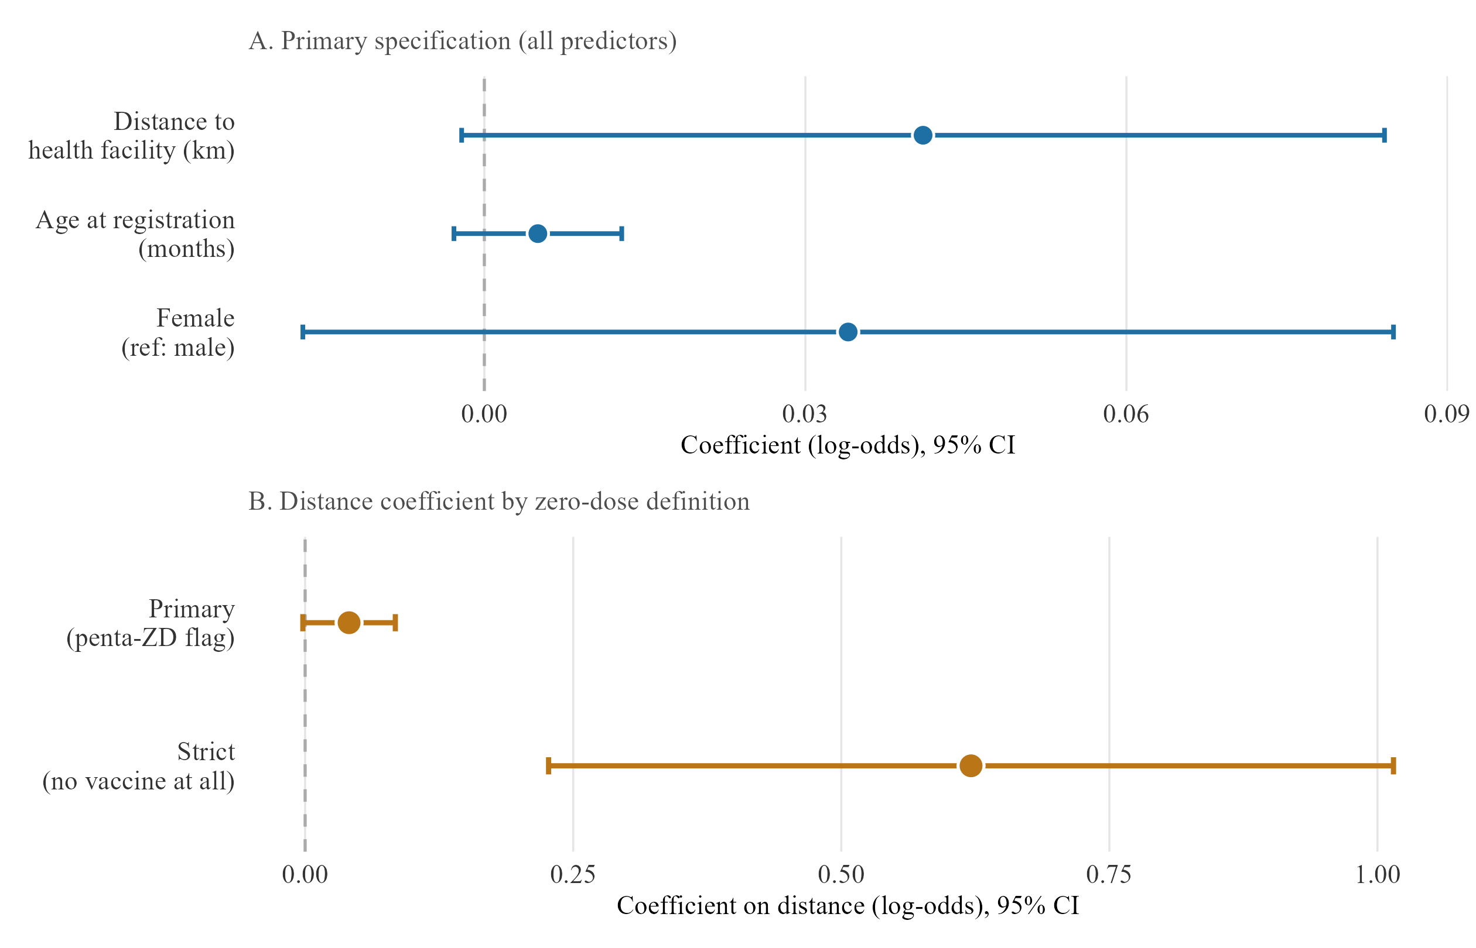
Figure 3.3. Zero-dose model — primary specification and definitional amplification
Panel A: coefficients and 95% confidence intervals for distance, age at registration and gender, under the primary zero-dose definition. Panel B: the distance coefficient under the primary versus strict zero-dose definition, with 95% confidence intervals.

Table 3.1a. Zero-dose model — regression summary
 | Primary definition | Strict definition
Distance to health facility (km) | 0.041 [-0.002, 0.084] | 0.621*** [0.227, 1.015]
Age at registration (months) | 0.005 [-0.003, 0.013] | 0.068*** [0.056, 0.08]
Female (ref: male) | 0.034 [-0.017, 0.085] | 0.035 [-0.043, 0.113]
N | 70314 | 70314
R² | 0.068 | 0.226
Estimates on the log-odds scale; 95% CIs in brackets; ward-clustered SE (definitions in Section II.C.i). ** p < 0.05 *** p < 0.01
Ward-level residuals from this model are examined separately in Appendix E.

C. Recovery model
Research question two asks what predicts successful recovery through defaulter tracing, and how far programme records can support the recovery rates they report.

i. Main results
The full tracing dataset comprises 38,913 attempts. A lag-time value, days since the child’s last recorded visit, can only be constructed where a prior visit exists in the facility visits table. This holds for 16,132 of these attempts, fewer than half, and the two subsets are unlikely to be equivalent. Children retained in the lag-time subset have, by construction, at least one prior recorded visit, meaning they were already somewhat engaged with the formal system before defaulting, a probably more reachable population than the full traced group.
SMS or phone contact, relative to home visits, is associated with higher odds of confirmed recovery across every specification (Table 3.1b): roughly a 56 per cent increase in the lag-time subset (β = 0.444, p < 0.01) and a 55 per cent increase in the full sample (β = 0.436, p < 0.001). This is reported as an association, not a claim that SMS is the more effective channel: the tracing table has no field recording whether an attempt was a first-line contact or an escalation after an earlier one failed, and DATHARM allows multiple attempts per child. If home visits are disproportionately reserved for cases that already failed to respond to SMS, as fieldwork suggests may happen, home-visit rows would systematically represent harder-to-reach cases, and this coefficient would partly reflect that sequencing rather than either channel’s intrinsic effectiveness. Ranking attempts chronologically by tracing date is a further research direction (Section V). There was no significant association between distance and recovery in either specification (95% CIs of [−0.355, 0.147] and [−0.171, 0.069], both crossing zero). Age at tracing reaches significance in the full sample, though the effect is negligibly small (β = −0.001, p < 0.01), and loses significance in the lag-time subset once days-since-visit is added (β = −0.005, 95% CI [−0.011, 0.001]), consistent with the two variables capturing overlapping information. The lack of an association between distance and recovery is a departure from the zero-dose model, where distance was the dominant predictor under the strict definition. A recovery attempt by phone or SMS does not require the physical travel that enrolment does.
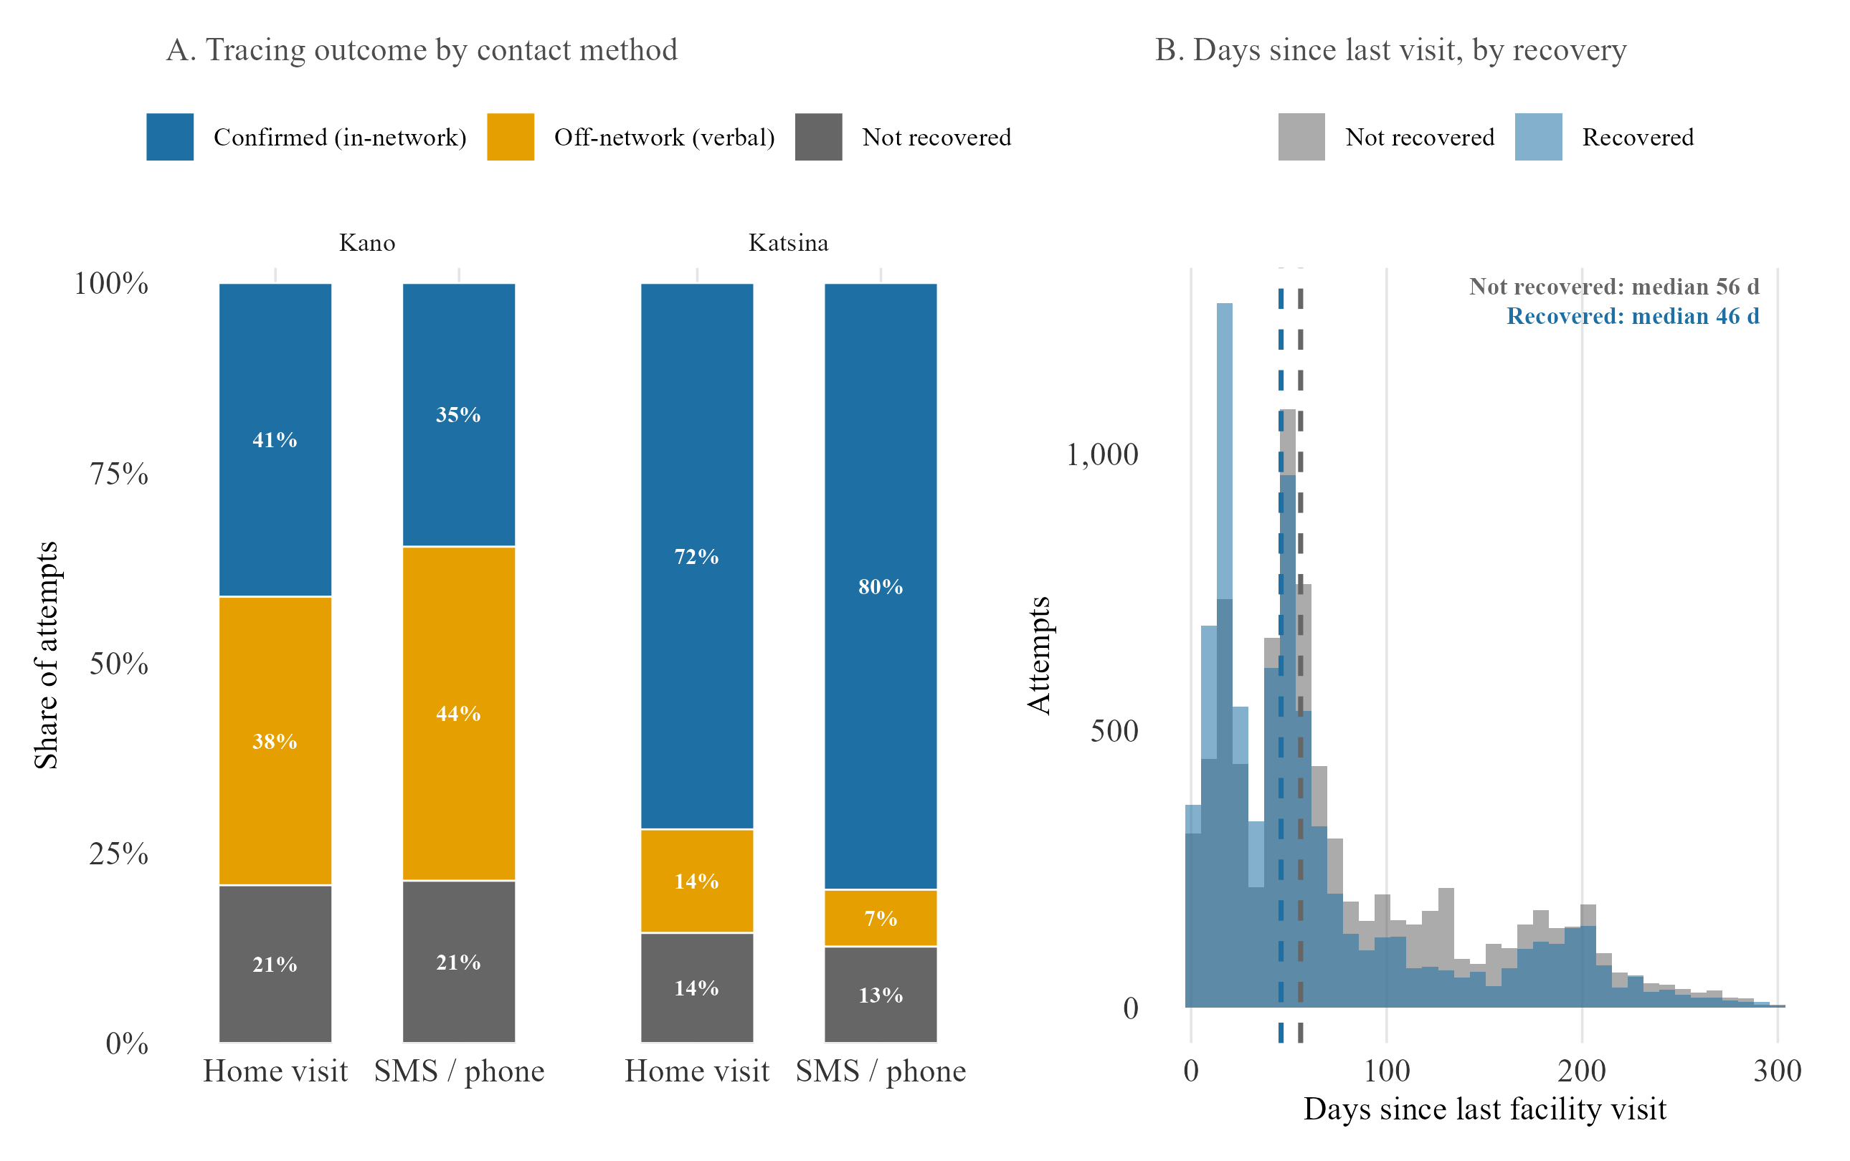
Figure 3.5. Tracing outcomes and timing
Panel A: tracing outcome (confirmed in-network, off-network verbal report, or not recovered) as a share of attempts, by contact method and state. Panel B: distribution of days between last recorded facility visit and tracing contact, recovered versus not-recovered cases, with median lines marked.
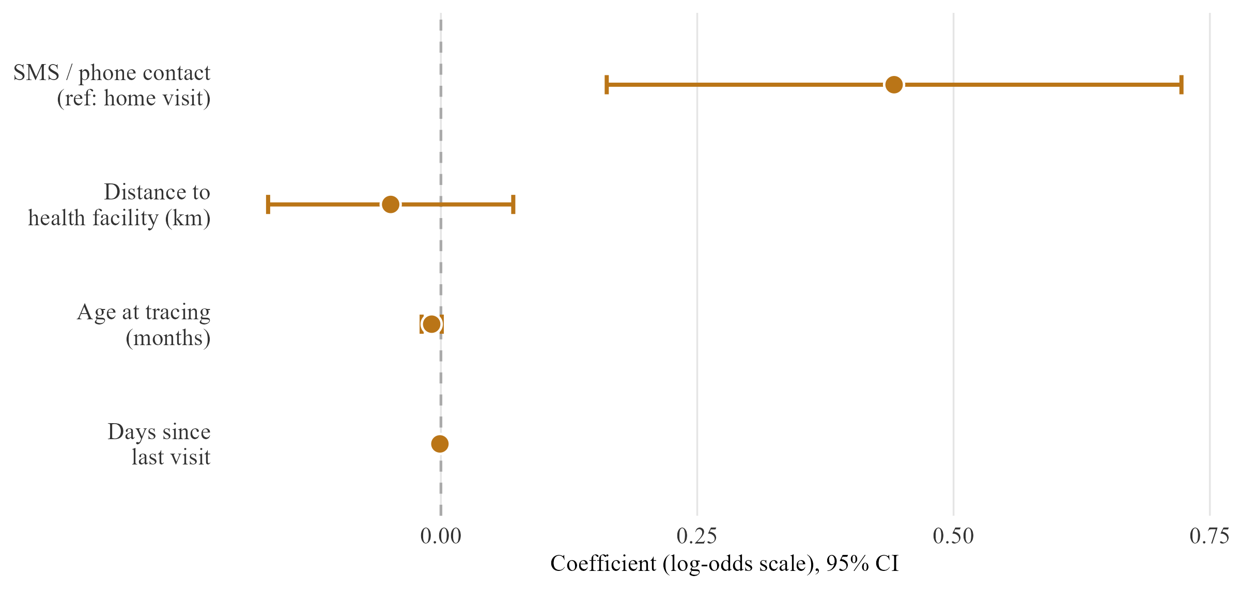
Figure 3.6. Recovery model — coefficient plot
Coefficients and 95% confidence intervals for SMS/phone contact, distance, age at tracing, and days since last visit, full sample and lag-time subset.

Table 3.1b. Recovery model — regression summary
 | Full sample | Lag-time subset
SMS / phone contact (ref: home visit) | 0.422*** [0.177, 0.667] | 0.442*** [0.162, 0.722]
Distance to health facility (km) | -0.104 [-0.361, 0.153] | -0.049 [-0.169, 0.071]
Age at tracing (months) | -0.010** [-0.02, 0] | -0.009 [-0.019, 0.001]
Days since last facility visit | n/a — not in full-sample spec | -0.001 [-0.003, 0.001]
N | 30768 | 16118
R² | 0.114 | 0.118
Estimates on the log-odds scale; 95% CIs in brackets; LGA-clustered SE. ** p < 0.05 *** p < 0.01
Recovered children also resolve faster than the tracing dataset as a whole. The median gap between last recorded visit and a successful contact is 46 days among recovered cases, against 56 among the full traced group. The state-level picture complicates a simple reading of the pooled SMS/phone coefficient in Table 3.1b (Figure 3.5). In Katsina, SMS-traced cases recover at 77.3 per cent, against 68.7 per cent for home visits. In Kano, the pattern reverses: home visits recover at 40.1 per cent, against 35.2 per cent for SMS. DATHARM’s Kano coordinator described this as a deliberate state-level operational choice, a separate explanation from the attempt-sequencing question raised earlier in this section. Both may be operating at once, and neither is resolvable from the pooled estimate. A formal interaction test on the lag-time subset finds no significant evidence that the SMS/phone advantage differs by state (β = −0.113, 95% CI [−0.628, 0.402]). This is not a complete answer: it does not separate the sequencing question raised above, and it covers only the lag-time subset rather than the full tracing dataset behind the state percentages just reported. Untangling both fully remains a next step (Section V).

ii. Strict versus reported recovery
The recovery rate reported by the programme depends heavily on how recovery is defined (Section II.C.i). The pooled rate is 42.6 per cent under the strict definition, rising to 77.2 per cent under the permissive one (Figure 3.7), which also counts self-reported off-network care confirmed only by a card check with no detail of what the card showed.
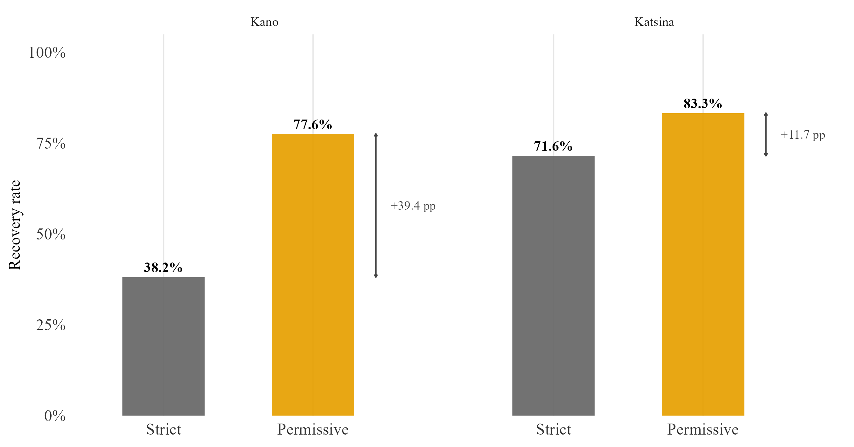
Figure 3.7. Strict versus permissive recovery rate by state
Recovery rate by state under the strict definition (a confirmed in-network vaccination record) and the permissive definition (which also counts self-reported off-network care confirmed only by an unverified card check; Section II.C.i). The bracket marks the percentage-point gap between the two definitions in each state.
A ward-level map of this off-network share, showing whether it clusters within particular LGAs or spreads evenly, is provided in Appendix F.
This is the clearest single illustration in this thesis of the verification gap described in Section II.A. A programme reporting the permissive figure, plausible given that the underlying protocol treats a card check as sufficient confirmation, would report a rate substantially higher than a stricter standard supports. This gap reflects what the underlying records can verify, rather than how well tracing is actually working.

D. Weather model
Research question three asks whether rainfall, heat and vegetation patterns explain any part of the variation in immunisation-seeking behaviour left unexplained above.

i. Descriptive overview
Daily facility visit counts are heavily zero-inflated. A substantial share of LGA-days record no visits at all, and the variance of these counts exceeds their mean by a wide margin in every LGA examined. This confirms the overdispersion anticipated in Section II.D, and rules out a standard Poisson specification on theoretical grounds. A closer look at which days are quiet suggests a calendar-driven rather than weather-driven explanation. Zero-visit days cluster around specific weekdays and known religious holiday periods (Figure 3.8), rather than spreading evenly across the year, a pattern more consistent with scheduled closures and social rhythm than any environmental driver. Section IV returns to why social and operational factors may dominate over weather here.
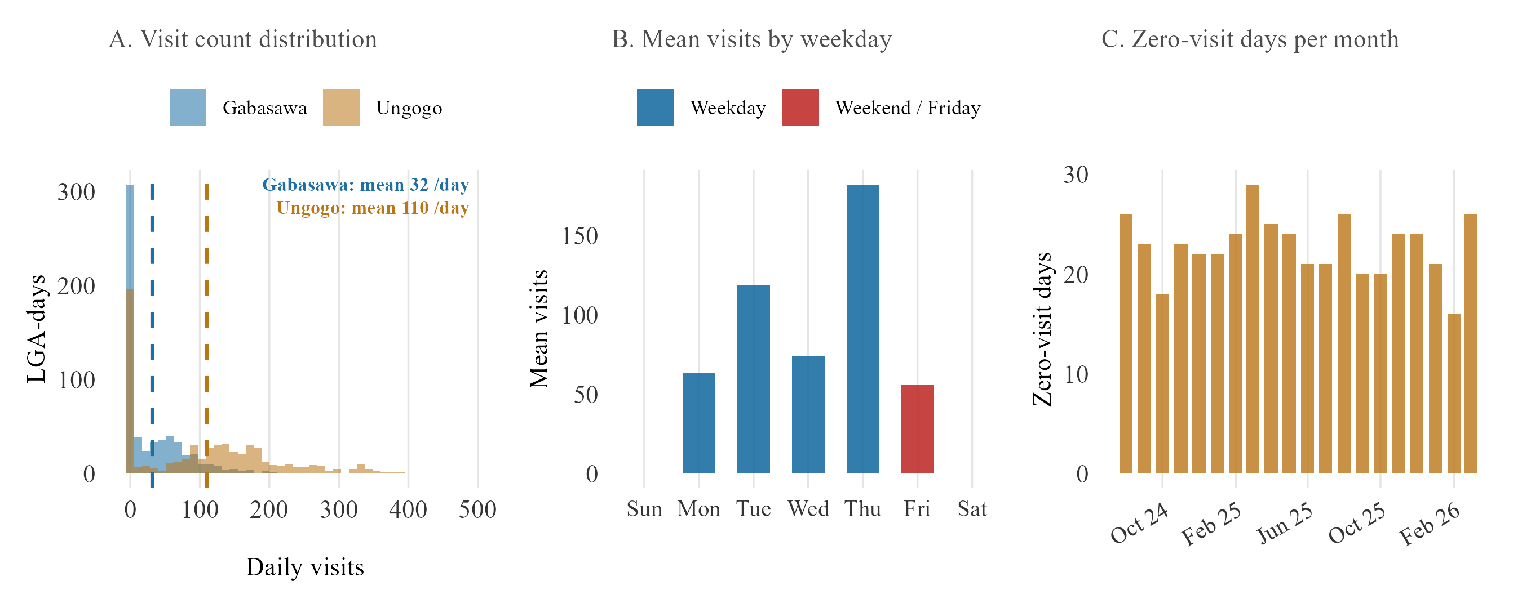
Figure 3.8. Daily facility visit diagnostics
Three-panel diagnostic for Kano’s Ungogo and Gabasawa LGAs. Panel A: distribution of daily facility visit counts, with the mean for each LGA marked. Panel B: mean visits by day of week, weekday versus weekend/Friday. Panel C: number of zero-visit days per month.

ii. Main results
None of the three weather variables tested, rainfall, heat, and vegetation, show a significant or directionally consistent effect on daily visit counts under the primary negative binomial specification (Table 3.2). Heat is the only one moving in the direction a hypothesis of heat deterring care-seeking would predict; rainfall and vegetation do not. A small number of monthly specifications return a statistically significant coefficient, but each traces to a limitation of a thin, two-site monthly panel, rather than to a genuine weather effect. In some cases there are too few degrees of freedom for a trustworthy standard error. In others, the fixed effects remove all variation within each site, leaving the coefficient to describe a fixed difference between Kano and Katsina rather than a response to changing conditions. The properly powered daily specifications are cleanly null throughout. A log-transformed OLS specification, reported in full in Appendix C, agrees with this primary specification in direction and in the absence of significance across all three variables, so the null result does not depend on which of the two specifications is used.

Table 3.2. Weather model — main results
 | Variable | Exposure measure | Coef. [95% CI] | Panel | Fixed effects | N | R²
W1 | Precipitation | Monthly precipitation anomaly (% of long-term average) | 0.004*** [0.004, 0.004] | Monthly | LGA | 40 | 0.923
W2 |  | Daily precipitation anomaly (% of long-term average) | -0.000 [-0.004, 0.004] | Daily | LGA, day-of-week, month-year | 1216 | 0.104
W3 | Heat | Extreme heat day (Universal Thermal Climate Index ≥ 38°C, binary) | 0.098 [-0.037, 0.233] | Daily | LGA, day-of-week, month-year | 1216 | 0.104
W4 |  | Daytime mean Universal Thermal Climate Index (°C, centred) | 0.045*** [0.02, 0.07] | Daily | LGA, day-of-week, month-year | 1216 | 0.105
W5 | Vegetation | NDVI seasonal level (centred on multi-year mean) | -0.029 [-0.662, 0.604] | Monthly | LGA | 40 | 0.150
W6 |  | NDVI within-baseline anomaly (centred, month-year adjusted) | -0.062*** [-0.062, -0.062] | Monthly | LGA, month-year | 40 | 0.264
Negative binomial coefficients and 95% confidence intervals for rainfall, heat and vegetation on daily facility visit counts, by specification. ** p < 0.05 *** p < 0.01
The null result also survives two robustness checks built specifically to address the concerns raised in Section II.C.ii (Table 3.3; Figure 3.9). Re-estimating with an exposure offset, which converts the outcome to a rate relative to each LGA’s enrolled population rather than a raw count, does not surface a significant effect for any of the three variables. Replacing the linear weather term with a spline, which allows a non-linear relationship, likewise finds nothing: the null is not an artefact of assuming a straight-line relationship where a curved one exists.

Table 3.3. Weather model — offset and non-linearity robustness
Variable | Original_CI | Offset_CI | NB_offset_CI | Non_linearity_check
Precipitation (daily anomaly) | 0.001 [-0.003, 0.005] | 0.000 [-0.004, 0.004] | -0.000 [-0.004, 0.004] | Yes — at least one spline term p<0.05
Heat (extreme-heat-day threshold) | -0.056 [-0.23, 0.118] | -0.057 [-0.231, 0.117] | 0.097 [-0.032, 0.226] | N/A — binary term, no non-linearity check built
Heat (continuous UTCI) | 0.019 [-0.008, 0.046] | 0.019 [-0.008, 0.046] | N/A — negative-binomial offset only built for the binary heat threshold | Yes — at least one spline term p<0.05
Vegetation (NDVI seasonal level) | -7.653*** [-7.653, -7.653] | 1.922*** [1.922, 1.922] | 1.915*** [1.597, 2.233] | Yes — at least one spline term p<0.05
Vegetation (NDVI within-baseline anomaly) | -0.062*** [-0.062, -0.062] | -0.002*** [-0.002, -0.002] | N/A — negative-binomial offset only built for NDVI seasonal level | N/A — no non-linearity check built for this term
Coefficient re-estimates under the original specification, an exposure-offset specification, and a negative-binomial offset specification (where built), alongside a check for non-linearity in the weather term. See Section II.C.ii for definitions of each robustness check.
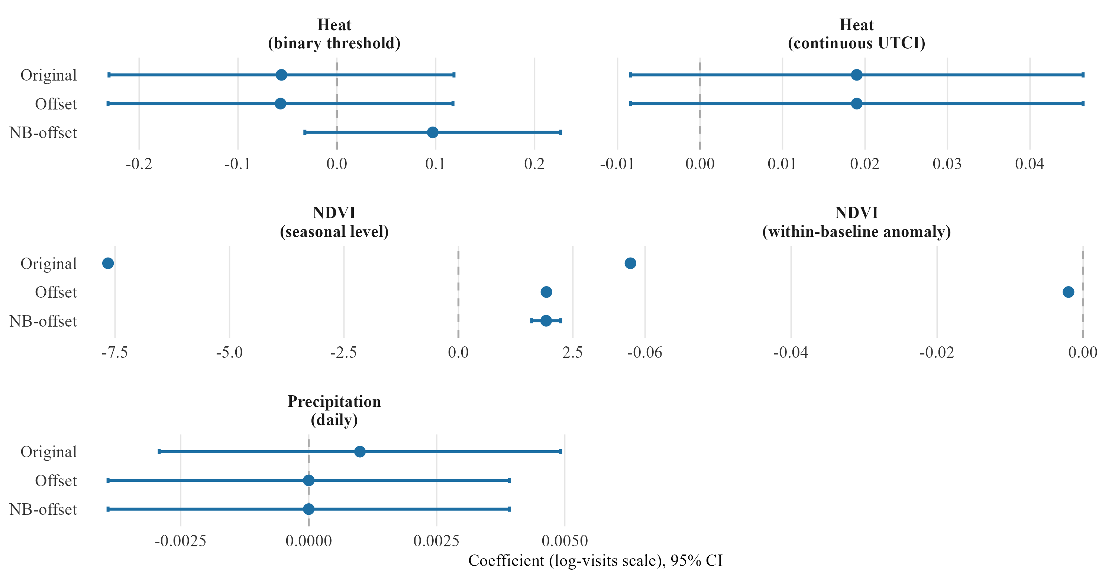
Figure 3.9. Weather effect estimates across specifications — offset, NB-offset and spline robustness
Coefficient point estimates and 95% confidence intervals for rainfall, heat and vegetation, under the original specification, an exposure-offset specification, and a negative-binomial offset specification (where built). Non-linearity checks are not plotted as points, since a spline term has multiple coefficients rather than one; results are reported in Table 3.3.
Each variable’s spatial distribution across Kano’s monitored LGAs is shown in Appendix D (Figures D.3-D.5).

IV. Discussion and Synthesis

A. What the data can show: reading the zero-dose and recovery findings together
Distance predicts ZD status once the strict definition is applied, an 87 per cent increase in the odds per additional kilometre. It shows almost nothing under the primary definition, a non-significant 4 per cent increase. Gender showed no significant association with zero-dose status in this analysis. This contrasts with parts of the DHS-based literature reporting gender effects in northern Nigeria, and may reflect how children come to be enrolled in MCHTrack rather than the absence of a true effect. Distance predicts almost nothing about recovery. Once a child is flagged and a tracing attempt begins, there is no detectable association between distance and the outcome, consistent with recovery here running through SMS and phone contact rather than physical travel (Section II.C.i). Section IV.D brings these quantitative findings together with corroborating field engagement (Table 4.2). The discussion here focuses on what the regressions alone show.
This split says something useful about DATHARM’s two stated problems: finding zero-dose children, and getting them vaccinated once found. They are not the same problem, and do not respond to the same fix. Physical reach, more outreach points, shorter travel distances, matters for the first. The second depends far more on contact method and speed than on geography. This asymmetry is sharpened by the strict-versus-primary ZD definition split, since distance only shows its full strength once zero-dose means genuinely no contact at all. A ward-level view of this model’s residuals, examined in Appendix E, shows a similar Kano-Katsina asymmetry but functions as a caveat on the model rather than a targeting signal.
The enumeration gap described in Section II.A (roughly one in five households missed, by the Kano coordinator’s estimate) cannot be checked against MCHTrack’s own records, but it points the same way as the regression. Distance almost certainly shapes who gets found at all, in ways this analysis, built entirely from children eventually enumerated, has no way to observe directly.
Field conversation with DATHARM’s Kano coordinator adds a further layer: recovery rates by contact method run in opposite directions in Kano and Katsina, home visits ahead in Kano and SMS ahead in Katsina (Section III.C.i). This thesis’s pooled estimate cannot on its own distinguish a state-level operational difference from the attempt-sequencing question raised in Section III.C.i. Treating the pooled SMS coefficient as evidence that SMS is the better channel would overstate what either the state-split numbers or the sequencing caveat can support.
The strict-versus-permissive recovery gap belongs in the same discussion: 42.6 per cent pooled under the strict definition, rising to 77.2 per cent under the permissive one (Section III.C.ii). This gap is not noise. It follows directly from the protocol in Section II.A, which allows a tracing case to close on the strength of a card check, with no record of what the card actually showed. Whichever figure DATHARM reports, the distance between the two is a fact about the limits of the underlying records, and no amount of further modelling will close it. Taken together, the same caution applies throughout this thesis’s first two models: each coefficient is real, but each also marks the edge of what MCHTrack’s records can confirm on their own.

B. Why the weather model came back null: reading it against Sindh and Miami
The same test has been run twice elsewhere, and both times it found something. Siddiqi et al. (2025) linked daily heat data to a real-time immunisation registry in Sindh, Pakistan, and found heat wave days significantly reduced immunisation delivery, with outreach hit harder than fixed-site delivery. Samano et al. (2021) linked daily heat and precipitation to an HIV clinic registry in Miami, and found both variables significantly increased missed appointments. Table 4.1 sets both alongside this thesis’s own result. Neither registry carries the enumeration gap or the verification gap documented in Section II.A: these comparators are unlikely to be entirely clean, but they are cleaner than MCHTrack on the dimensions this thesis can check.
Table 4.1. This thesis against the two closest registry-based precedents
Study | Setting | Registry | Exposure | Result
This thesis (2026) | Kano & Katsina, Nigeria | MCHTrack zero-dose tracking | Rainfall, heat, NDVI | Null — no significant effect on any variable (see weather table)
Siddiqi et al. (2025) | Sindh, Pakistan | Provincial electronic immunisation registry (132M doses) | Heat wave days | Significant reduction — outreach hit hardest (−21.2%), fixed-site least (−5.8%)
Samano et al. (2021) | Miami, USA | HIV clinic appointment registry | Extreme heat & precipitation | Significant increase in missed appointments (+13% for extreme precipitation)
Outcome, weather exposure, and reported direction and significance of effect for this thesis and the two closest registry-based precedents identified in Section I.C, together with the data-quality caveats attached to each.
Five explanations are worth weighing. They are not mutually exclusive, and several likely operate together, though the third and fourth share the same underlying limitation and are considered together below.
The first concerns what dominates the social calendar. Zero-visit days in this dataset cluster around specific weekdays and known religious holidays, rather than spreading evenly across the year (Section III.D.i). This leaves little room for weather to explain anything further, even if a real effect exists underneath it. This matches the field. Across conversations with DATHARM staff and two primary healthcare centre visits near Abuja, nobody named weather as a barrier, even when discussion turned directly to attendance. The barriers named instead were almost entirely social, gendered, and economic, echoing caregiver-focus-group and health-system-constraint studies elsewhere in northern Nigeria that likewise never mention weather (Bolarinwa et al., 2025; Etim et al., 2025). A null finding alongside this body of caregiver-reported barriers looks less like an absence and more like confirmation that other factors are doing the explanatory work weather might otherwise be expected to do.
The second concerns a larger, more severe shock crowding out a gentler one. Vaccination access across the wider Sahel tracks conflict and administrative breakdown far more closely than any environmental variable, with ZD rates in conflict-affected states reaching as high as 43 per cent (Sabahelzain et al., 2025). Kano and Katsina sit within this same security environment, and a population already absorbing insecurity, displaced administrative capacity, and disrupted supply chains may simply have little remaining sensitivity to a comparatively mild stressor like a hot day or a rainy week. Conflict, in this setting, is the more likely constraint on a household’s limited capacity to respond, ahead of weather.
The third and fourth explanations share a single limitation: MCHTrack’s facility visits table records only a date, not a time. It cannot see a caregiver shifting a visit to a cooler hour rather than skipping it altogether, a pattern found in Chinese park cellphone data during heatwaves (Zheng et al., 2023). It also cannot see reduced labour capacity and energy on hot days, found in wearable-sensor data from Burkina Faso farmers (Eggert et al., 2025). Either mechanism would produce the same null signal as simple deterrence, and this analysis cannot separate the three.
The fifth concerns the outcome variable itself, and is less comfortable than the first four. Siddiqi’s and Samano’s registries both record a clinical encounter that either happened or did not, while MCHTrack’s facility visits table carries the enumeration gap and the verification gap set out across Section II. A null result here therefore cannot carry the same weight as one against a cleaner outcome.
Taken together, weather may genuinely matter less here than in Sindh or Miami because conflict and social barriers dominate the explanatory space, because the data cannot see the time-shifting or labour-capacity channels through which a weather effect would most likely operate, or because the data itself is too noisy to detect a real but small effect. This thesis cannot distinguish between these explanations with the data as currently structured, a limitation Section V returns to.

C. Fieldwork as contextual grounding
The field material referenced throughout this chapter, conversations with DATHARM staff, two field visits to primary healthcare centres in the wider Abuja area, and internal reports shared by DATHARM, is not an independent qualitative study. No structured protocol was applied, and no formal coding was carried out. Its purpose is to help interpret the quantitative findings against what people working with the programme observe directly, in the manner of informal colleague commentary rather than a parallel research method. It is also where the household enumeration gap and the verification gap described in Section II.A first surfaced. Engaging directly with the people and systems generating the data under analysis is standard good practice for applied programme research, not a compromise that needs excusing.
Conversations covered DATHARM’s Kano and Katsina coordinators, the data manager, and staff encountered during the two facility visits, spanning enumeration practice, tracing protocol, and day-to-day barriers caregivers are seen to face. This material is used only where it corroborates or usefully complicates a finding that already stands on its own quantitatively, not as independent confirmation (Section IV.D).

D. Closing synthesis: convergence across methods
Three of this thesis’s findings, distance, timing, and recordkeeping, were each corroborated by field engagement at the point each came up earlier in this chapter. Weather’s apparent irrelevance was corroborated the same way, but by absence rather than agreement: nobody closest to the programme named it as a barrier either. None of this corroboration was gathered through a structured qualitative method, as Section IV.C made clear. It was observed informally, and is used here only where it supports a finding that already stands on its own.
Table 4.2. Convergence of quantitative findings and field observation
Theme | Quantitative | Field | Convergence
Distance | Predicts zero-dose status (β = 0.041 primary; 0.621 strict). No effect on recovery. | Coordinator: distance is the barrier to being found, not to being recovered by phone. | Agreement
Timing | SMS contact predicts recovery (β = 0.442). | Long-open cases described as harder to close; contact speed matters more than reach. | Agreement
Recordkeeping | Strict recovery 42.3% vs permissive 78.3%. | Card check closes a case with no record of what the card showed. Confirmed as protocol. | Agreement
Weather | Null across rainfall, heat, and NDVI, all specifications. | No programme staff named weather as a barrier in any conversation, even when prompted. | Agreement by absence
Four themes, distance, timing, recordkeeping and weather, each pairing a quantitative finding with the field material described in Section IV.C, and showing where the two agree (distance, timing, recordkeeping) versus where agreement is really an absence of any field mention at all (weather).
This agreement between a regression coefficient and an informal field account deserves to be taken seriously, but not overstated. As Section IV.C established, it is not independent confirmation in any rigorous sense. What it offers instead is a check against a real risk in data like MCHTrack’s: a coefficient can be statistically significant and still tell little about the world if the data behind it is thin in the wrong places. That risk looks smaller where the regression and the field account agreed, and larger where they did not, as with the ward-residual deviations examined in Appendix E, which sat in the state with the least reliable records. The supply-side gap discussed in Section V sits entirely outside what either could see.

V. Conclusion and Recommendations
This dissertation’s central question was what predicts ZD status and tracing effectiveness in MCHTrack, and whether weather explains any of what those two questions leave unexplained. Kano and Katsina are not unique, though. Any digital registry that layers community-health-worker outreach onto routine facility care in a decentralised, conflict-affected, low-resource health system faces the same structural pressures MCHTrack’s data expose. What follows treats MCHTrack as a case of that wider pattern, not a conclusion limited to it, before closing on what MCHTrack itself would need to do next.

A. Implications for digital immunisation registries
Any community-health-worker system layered onto routine immunisation delivery in a setting like Kano and Katsina faces the same underlying split. Finding children the system has missed, and getting them vaccinated once found, are different problems that respond to different levers. A registry’s reported performance is also only as trustworthy as what its data-entry protocol lets it verify. MCHTrack illustrates both halves of that split concretely.
Distance is the strongest predictor of ZD status once the strict definition is applied. Continued or expanded outreach into the most distant wards stands the best chance of finding children the current system is most likely to miss. This urgency is sharpened by the household enumeration gap. If roughly one in five households go unreached, as DATHARM’s own Kano coordinator estimates, the children furthest from a facility are also likely the least likely to be found at all. Distance loses almost all of its predictive power once a child is flagged and tracing begins, and SMS contact is associated with higher recovery in the pooled data. Section III.C.i’s caveats still apply. The raw recovery rates split unevenly by state, but a formal interaction test found no significant evidence of a state difference, and the analysis still cannot separate a genuine channel effect from attempt sequencing. Rather than invest in one channel on the strength of the pooled coefficient alone, the more defensible near-term step is the attempt-order analysis flagged below, so any shift in contact strategy rests on evidence the current data can actually support. The implication carries further than MCHTrack. Distance-based targeting belongs at the identification stage, not the follow-up stage, whenever recovery can be attempted by phone instead of a return visit.
Any registry that allows a case to close on an unverified confirmation step will generate a gap between what it reports and what it can prove. MCHTrack’s own numbers show how large that gap can get, 42.6 per cent recovery under the strict definition against 77.2 per cent under the permissive one. Neither figure is wrong. They answer different questions, and the gap between them is large enough to change how a funder or DATHARM’s own leadership might judge performance. Any reported recovery figure should state which definition produced it, and where possible both should be reported side by side. The gap was never hidden in the data. It was only ever uncollapsed.

B. What remains unresolved about weather, and why it matters beyond this setting
MCHTrack’s weather result illustrates a risk that applies to any registry like it. A real effect can hide behind structural gaps in what the registry records, and a flat coefficient cannot tell the difference between that and a genuine absence of effect. Section IV.B set out five candidate explanations for this null. None of them can be ruled out or chosen between on the evidence gathered here.
The temptation to choose anyway is worth resisting on purpose. Conflict dominance is the strongest candidate by reputation, but picking it as the answer would produce a tidier, unjustified conclusion, since nothing here rules out the other four. A structural-zero mixture model, separating the process generating zero-visit days from the count process on days something happens, was considered as a more direct test and not built given this project’s timeline. It remains the clearest next modelling step. Settling the question properly would need two things MCHTrack currently lacks, a time-of-day field on facility visits and some visibility into supply-side stockouts. A related next step on the recovery side is ranking tracing attempts chronologically for each child, using MCHTrack’s existing records and attempt dates, to test whether SMS’s association with recovery reflects channel effectiveness or simply which cases reach a second attempt.

C. Limitations
Three structural patterns run through the limitations below. Ward-level analysis built on routine digital health records, examined in Appendix E, tends to look most informative exactly where the records are least reliable. The recovery-reporting gap described above is not particular to MCHTrack’s own protocol. It follows wherever a case can close on an unverified confirmation step. And a system built around demand-side identification will, by construction, be blind to supply-side failure. Each is worth stating as a general proposition before returning to what it looks like in Kano and Katsina specifically. These are reasonable defaults for any digital immunisation-tracking system operating in a similar low-resource, conflict-affected setting, and organisations running comparable programmes across the region may find them worth checking against their own data before assuming their own numbers are cleaner.
In MCHTrack specifically, four limitations have run through this thesis. MCHTrack records children who are found, not children who exist, and the enumeration gap has no field anywhere in the system, so every ZD count inherits it silently. Katsina’s facility visit records carry a documented duplication problem (Appendix G), worked around here but not repaired, and its reliability degrades further later in the study period, the reason the weather model uses Kano alone. The verification gap described in Section II.A, a card check with no record of what it showed, produces the strict-versus-permissive recovery gap above, and the tracing table’s lack of an attempt-order field is a related shortcoming (Section III.C.i). The fourth limitation, MCHTrack’s demand-side design, is developed more fully below.
A facility visits row is created only when a vaccination is actually administered, so a caregiver who reaches a clinic and leaves without one, whether from a stockout, a missed opportunity, or any other supply-side failure, leaves no trace in the data at all. This blind spot is unlikely to be small. A Missed Opportunities for Vaccination assessment in Ondo State used exit interviews with caregivers who had already reached a health facility. It found that 32.8 per cent left without receiving an indicated vaccine, most during a visit made for an unrelated reason where no one offered it (Fatiregun et al., 2021). No equivalent assessment exists for Kano or Katsina, so this figure is evidence that the blind spot is plausible at scale elsewhere in Nigeria, not a direct estimate of its size in MCHTrack’s own data. MCHTrack cannot see this kind of gap by construction, and the null weather result in Section IV.B should be read with that limitation attached. A flat relationship between weather and visit counts could reflect genuinely undeterred caregivers, or a real effect diluted by a supply-side gap of unknown size.
A further limitation concerns what could not be measured even in principle. Household socioeconomic status, maternal education, and birth order are absent from MCHTrack’s fields entirely, and the system cannot check whether a caregiver’s account of a vaccination history was accurate. None of this is unique to MCHTrack. The specific numbers in this thesis belong to Kano and Katsina in this period, and none of it is claimed to travel further without the same check being run elsewhere.

D. Future research directions
Two directions extend beyond MCHTrack’s own setting. The first is whether weather affects immunisation-seeking behaviour in this region at all. Testing that properly would need a design built for the purpose, with a longer time span letting weather vary independently of any single conflict episode or religious calendar, and with fields capturing visit timing and supply-side stockouts directly.
The second direction is broader. It is whether the enumeration gap, the verification gap, and the supply-side blind spot identified here are general features of digital registries built this way in conflict-affected, low-resource settings, or specific to MCHTrack. Mantel et al. (2025) evaluated electronic immunisation registries and logistics systems across Guinea, Honduras, Rwanda, and Tanzania, but none of the four is conflict-affected or Sahelian, and none layers community-health-worker outreach onto routine care the way MCHTrack does. Applying the same evaluation framework to MCHTrack and to comparable systems elsewhere in Nigeria and the wider Sahel would test directly whether these three gaps travel with the setting or with the programme.
Digital immunisation registries make it possible to ask sharper questions about who a health system is missing and why. But a registry only shows what its own data-entry protocol lets it capture. That ceiling is not particular to MCHTrack. It was built to find children the health system was missing. The same scrutiny was applied here to MCHTrack’s own data, and to the weather question examined alongside it. Distance carries real predictive signal. The recovery-reporting gap is large enough to change how a programme’s performance gets judged. Weather, on this evidence, does not show an effect worth trusting yet.
A record is not the same as the life it tries to follow. A null result is not the same as an absence. The distance between what was found and what remains unresolved is where the real work of reaching every child will always have to continue.

Appendices
The appendices below provide supplementary detail referenced throughout the main text: analytical decisions, the R pipeline, and diagnostic material that supports but does not alter this dissertation’s primary findings.

Appendix A. Decision log
This log records the analytical decisions this dissertation’s methodology depends on, and why each was made. It is a companion to Chapter II rather than a repeat of it: Chapter II states what was done, this log states what the alternative would have been and why it was not chosen.
Deduplication key. A visit was treated as duplicated, and one copy removed, when the patient, visit date, health centre, and vaccines administered all matched exactly. The alternative, treating any row-level difference as a genuine second visit, was rejected because the duplication traced to a known technical cause (a device handover), not to a plausible clinical one.
Rimi LGA exclusion. Rimi was dropped from every primary analysis rather than corrected in place, because its data showed signs of retrospective entry that could not be distinguished, row by row, from genuine real-time records. Correcting a value assumes the correct value is knowable; here it was not.
GPS distance exclusion. A small number of geolocation values placed a child’s health facility over 100 kilometres away, well beyond any plausible distance within Kano or Katsina. These rows were treated as GPS recording errors and excluded rather than retained as genuine extreme values, since a distance error of this size would distort a fitted distance effect far more than it would inform one. The same rule is applied at source to every table this dissertation draws a distance variable from, so both the zero-dose and recovery models see an identically cleaned distance predictor.
Implausible-age exclusion. Age at registration and age at tracing are both derived from separate year, month, and week fields entered at the point of contact. A single mistyped or miscoded entry is enough to place a child’s derived age far outside any plausible value, in either direction: this revision found rows with a derived age above 180 months (15 years, an implausible age for an under-five programme) and rows with a derived age below zero (a negative age, which cannot be genuine under any reading of the data). Both are excluded from both models rather than capped or winsorised, on the same reasoning as the GPS distance rule: a value this implausible is far more likely to reflect a data-entry error than a real case, and capping it would still let an impossible value contribute to the fitted coefficients at its capped weight rather than removing it. Both cutoffs were set after the underlying distributions were inspected directly, not chosen arbitrarily in advance.
Weather model restricted to Kano. Katsina’s facility visit records degrade further in reliability after September 2025, beyond what the deduplication fix at source could offset. The zero-dose and recovery models still draw on both states, since their outcomes are binary and less sensitive to noise in a single count. The weather model draws on Kano alone, since a daily visit-count outcome is far more sensitive to residual noise than a binary one, and Katsina’s later-period data was not reliable enough to support that sensitivity.
Negative binomial treated as primary over log-transformed OLS. Daily facility visit counts are overdispersed relative to a Poisson assumption (Figure 2.3), which rules out Poisson and motivates a negative binomial specification. A log-transformed OLS specification was retained as a robustness check rather than dropped outright, since it makes different assumptions about the data-generating process; Appendix C shows the two agree throughout.
Strict and permissive definitions both reported. Chapter II’s verification gap, a card check with no record of what it showed, means any single recovery or zero-dose figure understates how much of it rests on assumption. Both definitions are reported side by side throughout this dissertation instead of choosing one, so a reader can see the range a single figure would otherwise hide.

Appendix B. Pipeline description
This dissertation’s quantitative analysis runs through eight R scripts, provided as supplementary material alongside a link to the project’s GitHub repository (see Candidate’s Contribution and Declaration). Each script has a single, stated purpose, run in sequence.
- 01_mchtrack_import.R imports and cleans the four raw MCHTrack tables, facility visits, linelisted enrolment, identified zero-dose, and defaulter tracing, for both states, applies the study window, and deduplicates each table at source. This is also where the Rimi LGA flag and the GPS distance exclusion described in Appendix A are applied.
- 02_chirps_import_analysis.R imports daily CHIRPS rainfall data, aggregates it to the LGA-day level, and fits the rainfall specifications of the weather model.
- 03_regression.R runs the child-level zero-dose and tracing-effectiveness regressions behind this dissertation’s first two research questions.
- 04_ward_residuals.R extracts and summarises the ward-level residuals from the zero-dose model, the source of Appendix E.
- 05_era5_import.R imports and quality-checks the ERA5-HEAT UTCI daily heat data for MCHTrack’s two heat-monitored sites in Kano.
- 06_era5_analysis.R fits the heat specifications of the weather model using the cleaned ERA5-HEAT series.
- 07_ndvi_import.R imports, cleans, and checks the dekadal NDVI vegetation-greenness series used as the vegetation exposure variable.
- 08_ndvi_analysis.R fits the NDVI specifications of the weather model.
Two further scripts sit outside this numbered sequence and are referenced elsewhere in this dissertation rather than counted among the eight: 09_data_investigations.R, which runs the data-quality checks behind Appendix G, and 10_visualizations.R, which builds every figure and table in the main text and appendices from the outputs of scripts 01 through 08.

Appendix C. Weather model: negative binomial and log-transformed OLS compared
A log-transformed OLS specification was estimated alongside the primary negative binomial models for all three weather variables, as set out in Section II.C.ii. Across precipitation, heat, and vegetation, OLS agrees with the primary NB specification in direction and in the absence of significance (Table C.1). The null result reported in the main text does not depend on which of the two specifications is used.
Table C.1. Weather model — negative binomial and OLS compared
Variable | Specification | Coef | SE | CI | Sig
Precipitation | Negative binomial — counts (primary) | 0.000 | 0.002 | [-0.0039, 0.0039] | n.s.
Precipitation | OLS — log(visits + 1) | 0.001 | 0.002 | [-0.0029, 0.0049] | n.s.
Heat | Negative binomial — counts (primary) | 0.098 | 0.069 | [-0.0372, 0.2332] | n.s.
Heat | OLS — log(visits + 1) | -0.056 | 0.089 | [-0.2304, 0.1184] | n.s.
NDVI | Negative binomial — counts (primary) | -0.029 | 0.323 | [-0.6621, 0.6041] | n.s.
NDVI | OLS — log(visits + 1) | -0.059 | 0.338 | [-0.7215, 0.6035] | n.s.
Negative binomial and log-transformed OLS coefficients, with 95% confidence intervals, for rainfall, heat and vegetation.

Appendix D. Distributions and diagnostics for the main outcome and predictor variables
Every predictor behind the zero-dose and recovery models was checked for extreme values, implausible outliers, and correlation with the model’s other predictors before either model was fitted. None of these checks changed which specification this dissertation treats as primary. The figures below cover what these checks produced that the main text does not already show. They also include the spatial distribution of each weather variable. Real geographic variation in rainfall, heat, and vegetation greenness is what makes a null result across all three interpretable, rather than a symptom of flat data with nothing to detect.
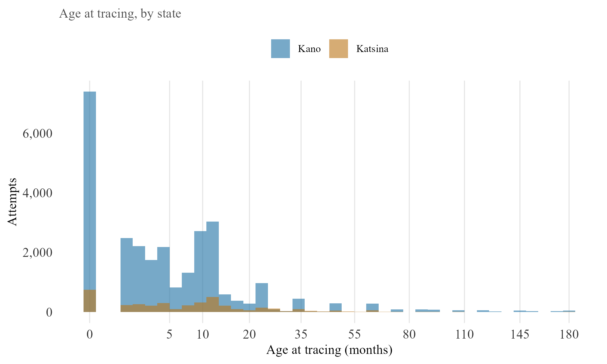
Figure D.1. Age at tracing, by state (Model B, not reported elsewhere)
Figure D.1. Age at tracing, by state. Histogram of age at tracing (months), split by state. The only continuous variable used in either model with no existing distribution reported elsewhere in this dissertation. The x-axis uses a square-root scale, since most attempts involve children under two years old but a small number extend out to the study’s 180-month cutoff; a linear axis would compress the range where nearly all the data sits.
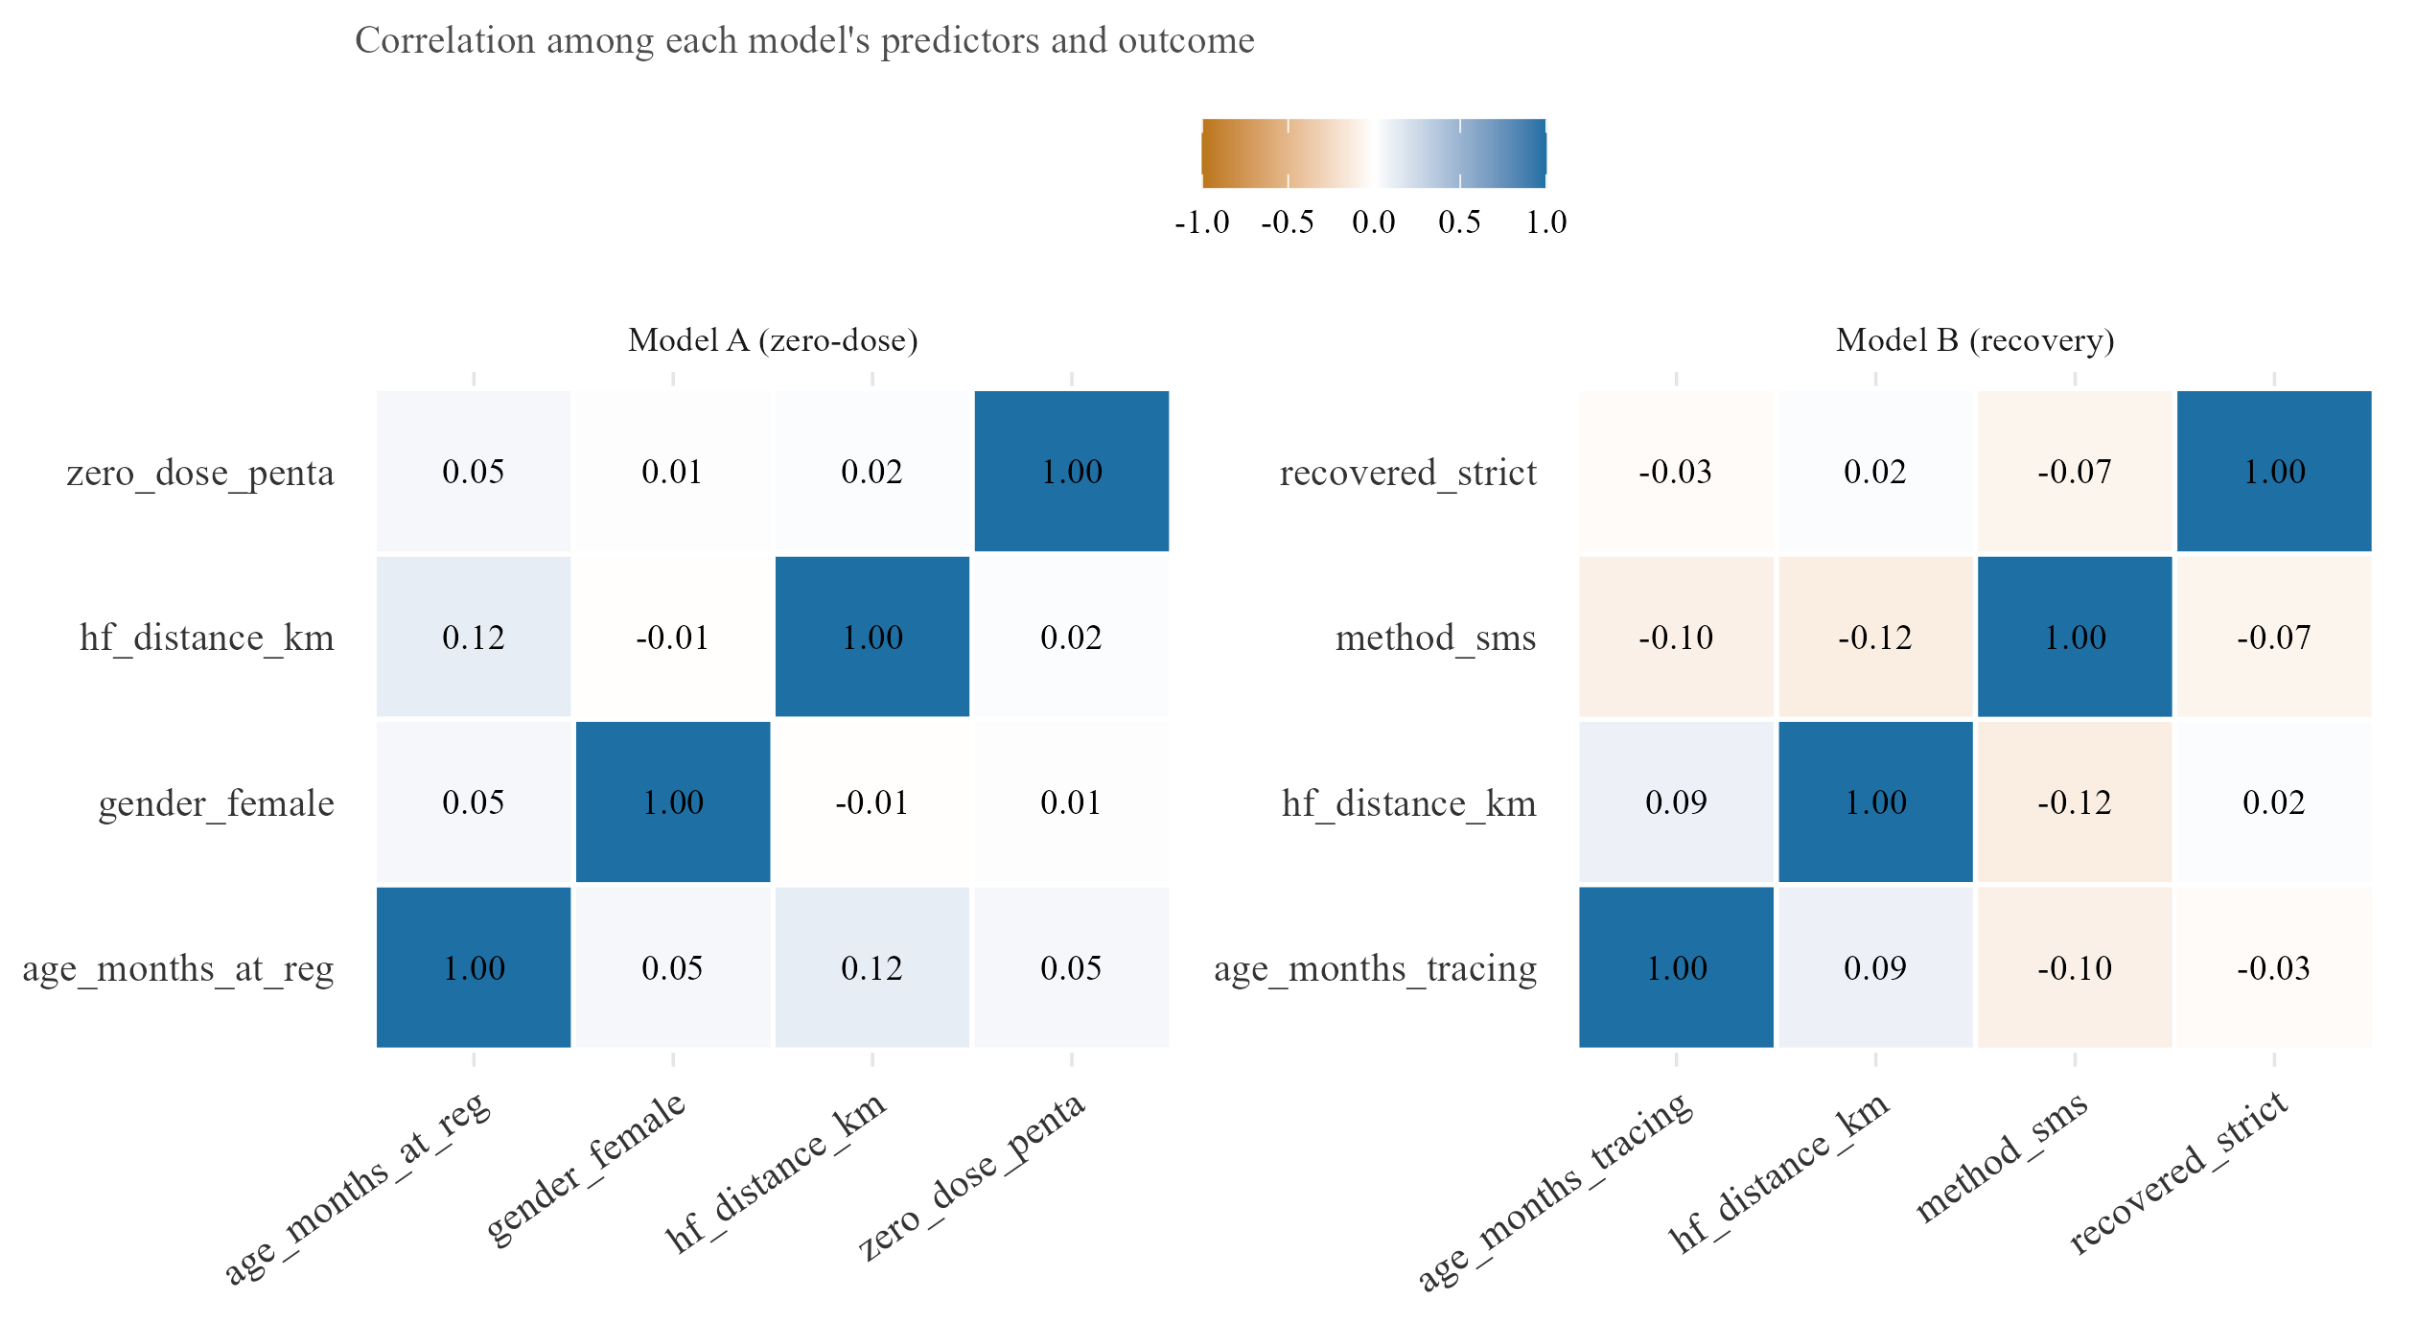
Figure D.2. Correlation among each model’s predictors and outcome (Pearson)
Figure D.2. Correlation among each model’s predictors and outcome. Pearson correlation heatmaps for the zero-dose model’s and the recovery model’s own predictor and outcome sets, side by side. Included to let a reader check for collinearity directly rather than infer it from the regression output alone.
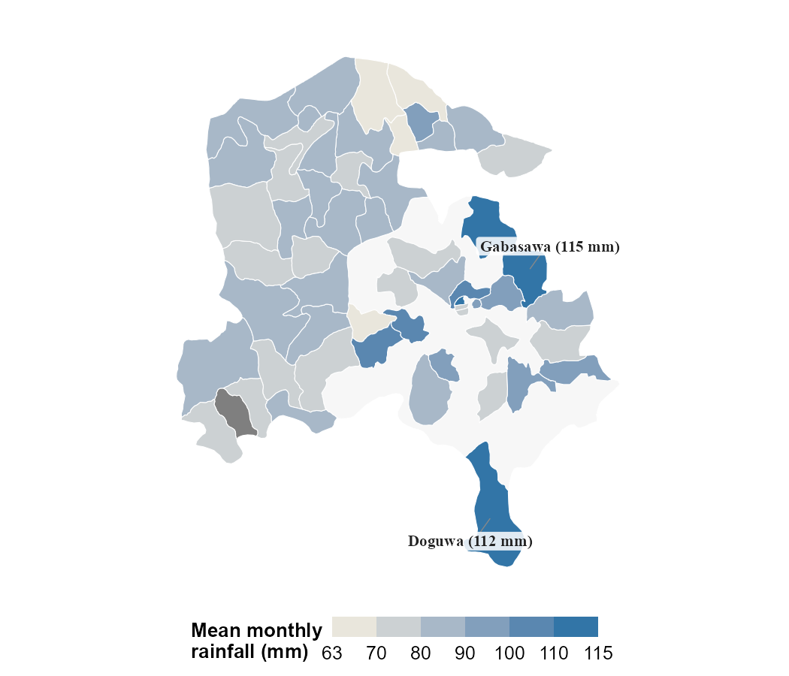
Figure D.3. Mean monthly rainfall by LGA (CHIRPS)
Figure D.3. Mean monthly rainfall by LGA (CHIRPS). Mean monthly rainfall by LGA, averaged across the full study window. Administrative boundaries: GADM (2026), version 4.1.
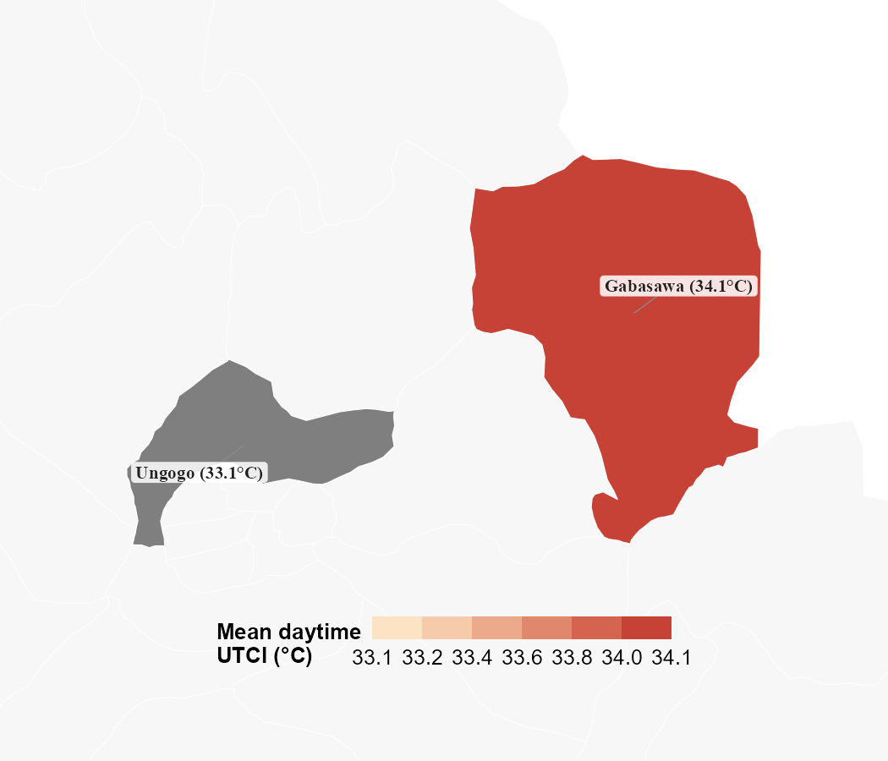
Figure D.4. Mean daytime heat (ERA5/UTCI) for Kano’s monitored LGAs
Figure D.4. Mean daytime heat by LGA (ERA5/UTCI). Covers only Ungogo and Gabasawa in Kano, the full extent of the ERA5/UTCI panel used in the heat model, not a display choice. Administrative boundaries: GADM (2026), version 4.1.
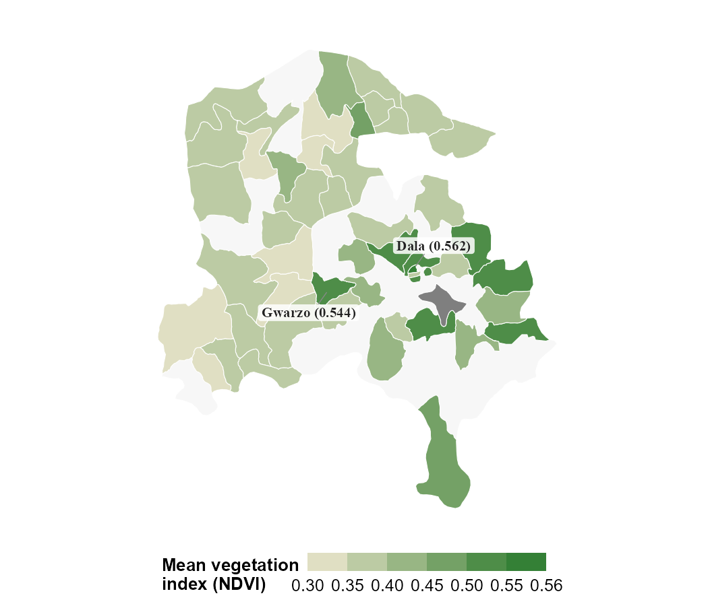
Figure D.5. Mean vegetation greenness (NDVI) by LGA
Figure D.5. Mean vegetation greenness (NDVI) by LGA. Averaged across the full study window. Administrative boundaries: GADM (2026), version 4.1.

Appendix E. Ward-level residuals from the zero-dose model
The zero-dose model’s ward-level fixed effects can also be examined directly, as residuals showing which wards have more or fewer zero-dose children than the model predicts once distance, age, and gender are accounted for. In Katsina, this exercise identifies several wards with markedly higher residuals than anywhere in Kano: Wagini, in Safana LGA, sits 59.5 percentage points above prediction (n = 37), Babban Duhu B, also in Safana, 51.5 points above (n = 80), and a further cluster across Mani and Funtua LGAs each exceeding 20 points, including Kurfeji (Mani, +46.8pp, n = 42), Makera (Funtua, +37.5pp, n = 351), Duwan Makau (Mani, +27.9pp, n = 41), and Bakiyawa (Batagarawa, +25.3pp, n = 378). In Kano, by contrast, the largest residual found, Maraku ward in Gabasawa LGA, reaches only 13.2 percentage points above prediction (n = 89), and the overall spread across Kano’s wards is markedly flatter.
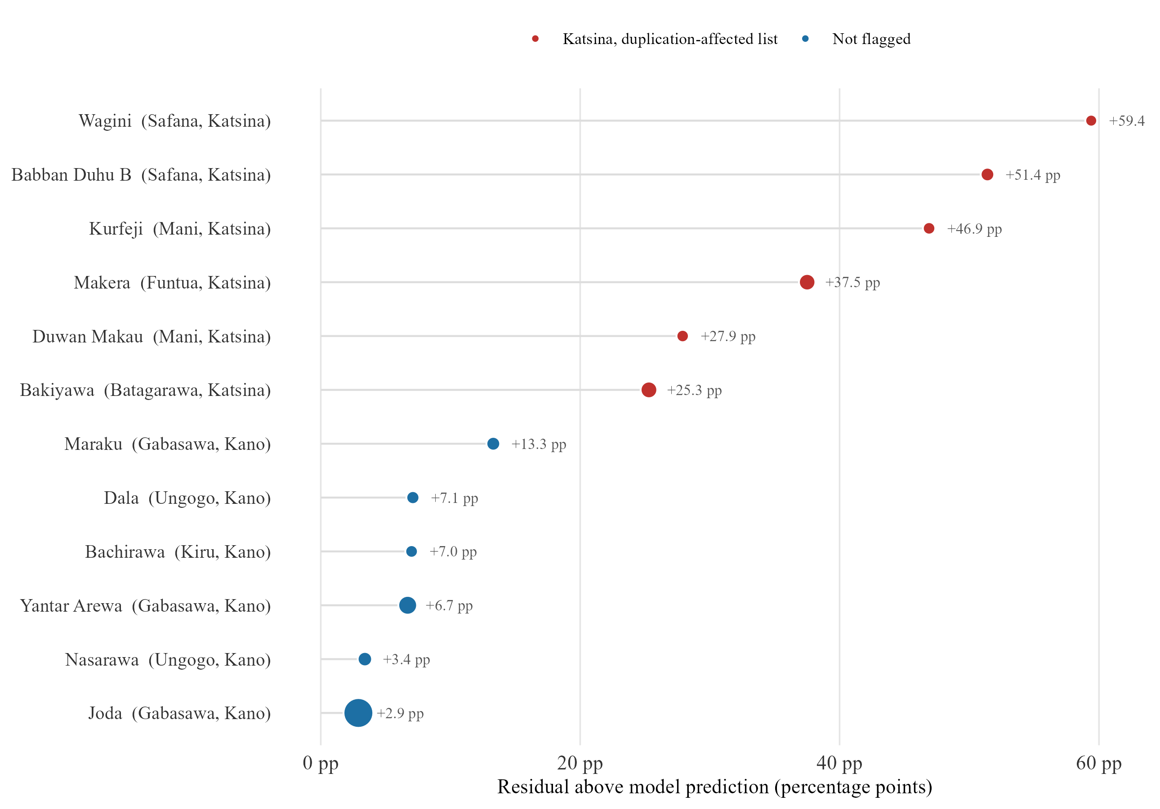
Figure 3.4. Ward-level residuals from the zero-dose model
Figure E.1. Ward-level residuals, ranked by magnitude. The six wards with the largest positive residuals in each state (observed minus model-predicted zero-dose rate), ordered by magnitude within state. Point size indicates the number of enrolled children in the ward; wards on the duplication-affected Katsina facility list (Section II.A) are marked in a different colour.
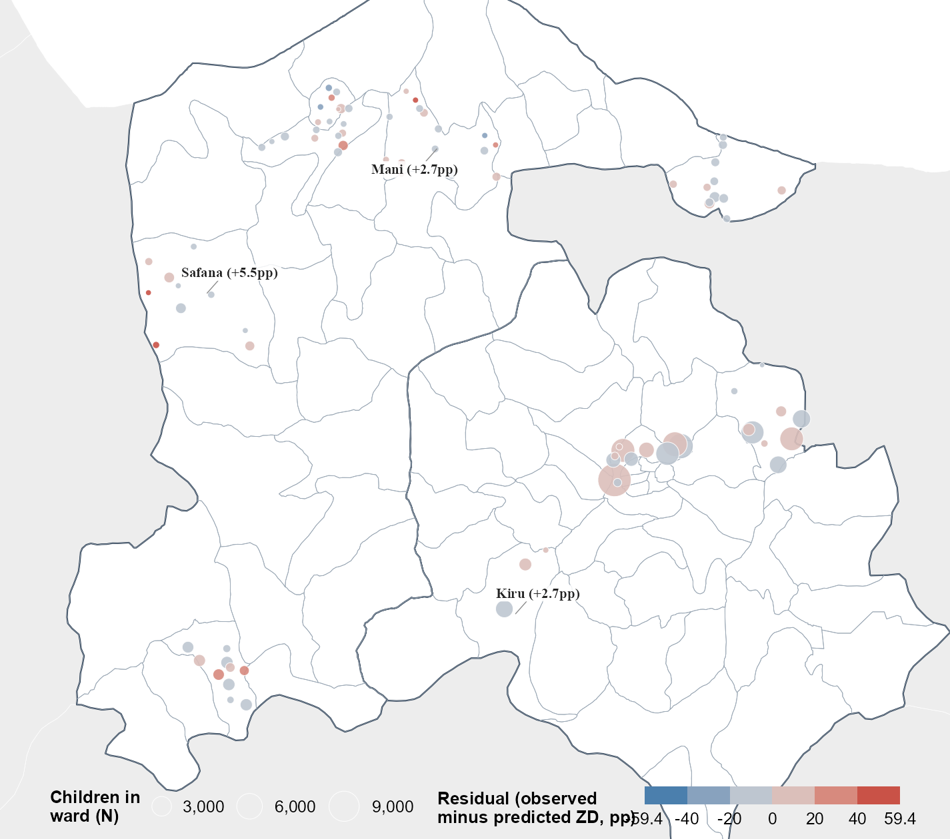
Figure 3.4b. Ward-level zero-dose model residuals, mapped
Figure E.2. Ward-level residuals, mapped. Colour indicates the residual (observed minus predicted zero-dose rate), centred at zero; point size indicates the number of children enrolled in the ward. Labelled LGAs are the top three by mean residual. Administrative boundaries: GADM (2026), version 4.1.
This contrast should not be read as evidence that Katsina has more genuine pockets of unmet need than Kano. Katsina is also the state where a device handover produced duplicate records in 38.9 per cent of facility visits (Appendix G). A ward whose visit records were inflated or distorted by this duplication could show an artificially large residual having nothing to do with true underlying need. Kano’s flatter spread, meanwhile, may simply reflect that the state’s more even data quality leaves less room for any single ward to stand out, rather than indicating its zero-dose burden is genuinely more uniform.
Taken together, the two states illustrate a limit of ward-level analysis built on routine programme data, rather than a usable targeting map. The same gaps that produce noisy data, incomplete enumeration, inconsistent verification, duplicate entries, can also produce the kind of extreme value a residual analysis is designed to detect. Cleaner data may simply show less variation for the same reason, not because the underlying reality is more even, but because there is less room for error to generate an outlier. The state with the most striking residuals here, Katsina, is also the state whose records are least trustworthy at this resolution, and the state whose records are most trustworthy, Kano, shows too little variation to act on with confidence. The appropriate response is not a different statistical model but a verification step before any ward-level finding informs a resource decision. Any ward flagged this way is a candidate for a field visit or a card check, not a confirmed allocation priority.

Appendix F. Off-network share of recovered defaulters, by ward
Section III.C.ii reports the off-network recovery share, self-reported care outside MCHTrack’s own referral network, at state level. A ward-level view of the same measure shows whether it clusters within particular LGAs or spreads evenly, a distinction the state-level comparison cannot make visible.
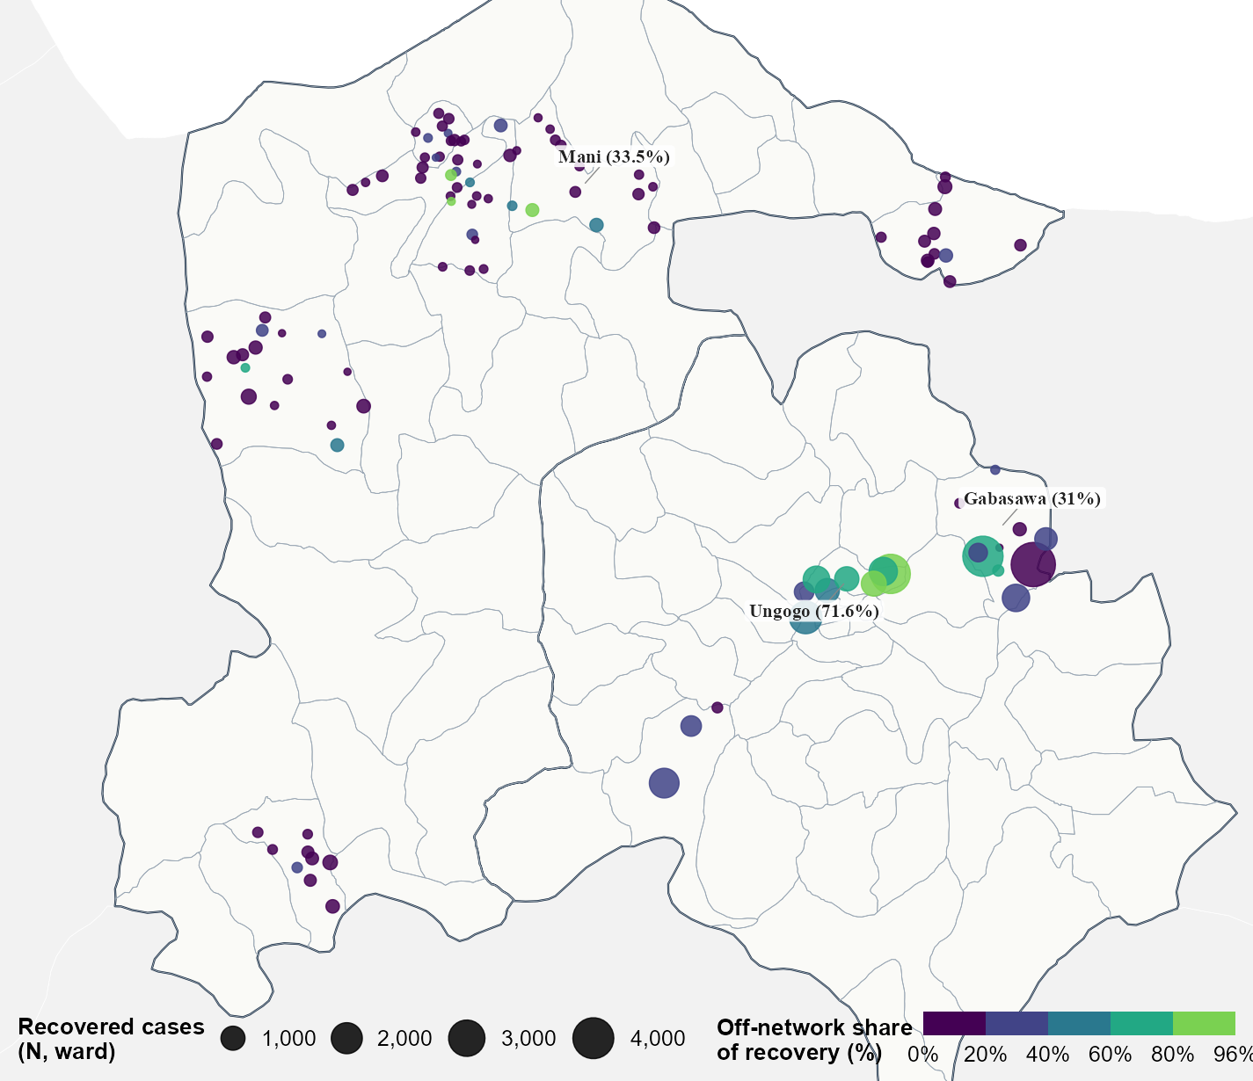
Figure 3.7b. Off-network share of recovered defaulters, by ward
Figure F.1. Off-network share of recovered defaulters, by ward. Off-network share of recovered defaulter-tracing cases, mapped by ward, restricted to wards with at least five recovered cases. Labelled LGAs are the top three by this share among LGAs with at least twenty recovered cases. Administrative boundaries: GADM (2026), version 4.1.

Appendix G. DATHARM data audit summary
This dissertation’s analytic sample was built after an audit of DATHARM’s raw MCHTrack exports, conducted jointly with DATHARM’s data manager. Three issues were identified and corrected before any modelling began.
Duplicate records affected two of the four tables unevenly by state. Katsina’s facility visits table contained 38.9 per cent duplicate rows and its linelisted table 22.1 per cent; Kano was comparatively unaffected. Both were traced to a device handover that caused records to sync more than once rather than to genuine repeat visits. A duplicate was defined as an identical combination of patient, visit date, health centre, and vaccines administered, on the reasoning that this combination recurring is far more likely to reflect one visit entered twice than two distinct visits happening to share every recorded field. Affected rows were removed at source, before any table was used in further analysis.
A small number of geolocation values in the linelisted table placed a child’s health facility over 100 kilometres away, well beyond any plausible distance within Kano or Katsina. These were treated as GPS recording errors and excluded rather than treated as genuine extreme values.
A small number of LGAs, Rimi among them, showed signs of data entered retrospectively rather than at the time of the encounter it recorded. Since backfilled entries cannot be checked against the same timeliness and completeness standard as the rest of the dataset, Rimi was excluded from every primary analysis rather than corrected, since there was no reliable way to distinguish a genuine record from a reconstructed one within it.
The full step-by-step exclusion waterfall, from 101,312 raw household enumeration rows to the 71,124-child primary analytic sample and the 70,314-child regression sample, appears in Section III.A and Figure 3.2. One step in that waterfall is worth restating here: children with an implausible derived age, below zero or above 180 months, are excluded from both models in both directions, as data-entry errors rather than genuine cases (Decision Log, Appendix A). Whatever the exact count at any given step, the same caution about non-random narrowing applies throughout: a household enumerated incompletely is also more likely to have incomplete distance or location data, which biases the analytic sample toward more thoroughly documented cases, a limitation that runs through every zero-dose estimate in this dissertation.

References
Full source details for every citation in the main text and appendices, in Harvard style.
Bergé, L. (2018) ‘Efficient estimation of maximum likelihood models with multiple fixed-effects: the R package FENmlm’, CREA Discussion Papers, 2018-13.
Blanford, J.I., Kumar, S., Luo, W. and MacEachren, A.M. (2012) ‘It’s a long, long walk: accessibility to hospitals, maternity and integrated health centers in Niger’, International Journal of Health Geographics, 11, p. 24.
Bolarinwa, O.A., Salaudeen, G.A., Lar, L., Alhaffar, M., Abdelmagid, N., McGowan, C.R., Adesoro, O., Valentine, P., Ahmed, T., Clarke, A., Makunja, S. and Akande, T.M. (2025) ‘Barriers and enablers to childhood immunization in high zero-dose burden communities in Kano and Lagos states, Nigeria’, Vaccine, 64, p. 127754.
Carnell, M.A. and Guyon, A.B. (1990) ‘Nutritional status, migration, mortality, and measles vaccine coverage during the 1983–1985 drought period: Timbuktu, Mali’, Journal of Tropical Pediatrics, 36(3), pp. 109–113.
Copernicus Climate Change Service, Climate Data Store (2026) Thermal Comfort Indices Derived from ERA5 Reanalysis. Available at: https://cds.climate.copernicus.eu/datasets/derived-utci-historical (Accessed: 14 May 2026).
DATHARM (2026) MCHTrack for Zero Dose Project. Available at: https://datharm.org/ (Accessed: June 2026).
Di Napoli, C., Barnard, C., Prudhomme, C., Cloke, H.L. and Pappenberger, F. (2021) ‘ERA5-HEAT: a global gridded historical dataset of human thermal comfort indices from climate reanalysis’, Geoscience Data Journal, 8(1), pp. 2–10.
Eggert, E., Gunga, H., Sié, A., Ouermi, L., Ouédraogo, W.A., Kwaro, D., Sauerborn, R., Bunker, A., Barteit, S., Bärnighausen, T. and Maggioni, M.A. (2025) ‘Physical effort during labour and behavioural adaptations in response to heat stress among subsistence farmers in Burkina Faso: a gender-specific longitudinal observational study’, The Lancet Planetary Health, 9(12), 101344.
Etim, E.O., Odiachi, A., Dougherty, L., Alabi, M., Adetunji, A. and Adedimeji, A. (2025) ‘Understanding caregivers’ and community influencers’ perspectives on the barriers to childhood immunisation in Northern Nigerian States with public-private partnerships in routine immunisation programme’, BMC Public Health, 25, p. 1471.
Farrenkopf, B.A., Zhou, X., Shet, A., Olayinka, F., Carr, K., Patenaude, B., Chido-Amajuoyi, O.G. and Wonodi, C. (2023) ‘Understanding household-level risk factors for zero dose immunization in 82 low- and middle-income countries’, PLOS One, 18(12), e0287459.
Fatiregun, A.A., Nic Lochlainn, L., Kaboré, L., Dosumu, M., Isere, E., Olaoye, I., Akanbiemu, F.A., Olagbuji, Y., Onyibe, R., Boateng, K., Banda, R. and Braka, F. (2021) ‘Missed opportunities for vaccination among children aged 0–23 months visiting health facilities in a southwest State of Nigeria, December 2019’, PLOS One, 16(8), e0252798.
Federal Ministry of Health and National Primary Health Care Development Agency (2013) National Routine Immunization Strategic Plan 2013–2015: Intensifying Reaching Every Ward through Accountability. Abuja: Federal Republic of Nigeria.
Funk, C., Peterson, P., Landsfeld, M., Pedreros, D., Verdin, J., Shukla, S., Husak, G., Rowland, J., Harrison, L., Hoell, A. and Michaelsen, J. (2015) ‘The climate hazards infrared precipitation with stations — a new environmental record for monitoring extremes’, Scientific Data, 2, 150066.
GADM (2026) GADM database of Global Administrative Areas, version 4.1. Available at: https://gadm.org (Accessed: July 2026).
Gavi, the Vaccine Alliance (2025) In Katsina, Nigeria, a homegrown mobile app is helping get vaccines to vulnerable kids. Available at: https://www.gavi.org/vaccineswork/ (Accessed: June 2026).
GBD 2023 Vaccine Coverage Collaborators (2025) ‘Global, regional, and national trends in routine childhood vaccination coverage from 1980 to 2023 with forecasts to 2030: a systematic analysis for the Global Burden of Disease Study 2023’, The Lancet, 406(10500), pp. 235–260.
Ghinai, I., Willott, C., Dadari, I. and Larson, H.J. (2013) ‘Listening to the rumours: what the northern Nigeria polio vaccine boycott can tell us ten years on’, Global Public Health, 8(10), pp. 1138–1150.
Guagliardo, M.F. (2004) ‘Spatial accessibility of primary care: concepts, methods and challenges’, International Journal of Health Geographics, 3, p. 3.
Haque, M.R., Parr, N. and Muhidin, S. (2019) ‘Parents’ healthcare-seeking behavior for their children among the climate-related displaced population of rural Bangladesh’, Social Science & Medicine, 226, pp. 9–20.
Jegede, A.S. (2007) ‘What led to the Nigerian boycott of the polio vaccination campaign?’, PLOS Medicine, 4(3), e73.
Joseph, N.K., Macharia, P.M., Ouma, P.O., Mumo, J., Jalang’o, R., Wagacha, P.W., Achieng, V.O., Ndung’u, E., Okoth, P., Muñiz, M., Guigoz, Y., Panciera, R., Ray, N. and Okiro, E.A. (2020) ‘Spatial access inequities and childhood immunisation uptake in Kenya’, BMC Public Health, 20, p. 1407.
MacDonald, N.E. and SAGE Working Group on Vaccine Hesitancy (2015) ‘Vaccine hesitancy: definition, scope and determinants’, Vaccine, 33(34), pp. 4161–4164.
Mantel, C., Hugo, C., Federici, C., Sano, N., Camara, S., Rodriguez, E., Castillo, L., Condo, J., Irakiza, P., Sabi, I., Nyanda, E., Olomi, W., Cavazza, M., Mangiaterra, V., Verykiou, M., Ferenchick, E., Torbica, A., Cherian, T. and Malvolti, S. (2025) ‘Impact of electronic immunization registries and electronic logistics management information systems in four low- and middle-income countries: Guinea, Honduras, Rwanda, and Tanzania’, Vaccine, 54, 127066.
Mills, A. (2005) ‘Mass campaigns versus general health services: what have we learnt in 40 years about vertical versus horizontal approaches?’, Bulletin of the World Health Organization, 83(4), pp. 315–316.
Miraj, F., Iftikhar, S., Siddique, M., Dharma, V.K., Shah, M.T., Siddiqi, D.A. and Chandir, S. (2024) ‘Leveraging data from a provincial electronic immunization registry to analyze immunization coverage, timeliness, and defaulters among 8.8 million children from the 2018 to 2023 birth cohorts in Sindh Province, Pakistan’, Vaccines, 12(12), p. 1327.
Nagata, J.M., Epstein, A., Ganson, K.T., Benmarhnia, T. and Weiser, S.D. (2021) ‘Drought and child vaccination coverage in 22 countries in sub-Saharan Africa: a retrospective analysis of national survey data from 2011 to 2019’, PLOS Medicine, 18(9), e1003678.
National Primary Health Care Development Agency (NPHCDA) (2022) Zero-dose children data, Kano State. Abuja: NPHCDA.
Ryman, T. and Brison, M. (2024) Zero Dose Learning Agenda. Gavi Zero Dose Learning Week, 11 September 2024.
Sabahelzain, M.M., Dwyer, H., Abimbola, S. and Leask, J. (2025) ‘Implications of conflict on vaccination in the Sahel region’, BMJ Global Health, 10(1), e016496.
Samano, D., Saha, S., Kot, T.C., Potter, J.E. and Duthely, L.M. (2021) ‘Impact of extreme weather on healthcare utilization by people with HIV in metropolitan Miami’, International Journal of Environmental Research and Public Health, 18(5), p. 2442.
Siddiqi, D.A., Iftikhar, S., Anfossi, C.M., Siddique, M., Shah, M.T., Dharma, V.K., Mehmood, M., Setayesh, H., Sodhar, I.A., Malik, F.R. and Chandir, S. (2025) ‘Assessing the impact of heat waves on childhood immunization coverage in Sindh, Pakistan: insights from 132.4 million doses recorded in the provincial electronic immunization registry (2018–2024)’, Vaccine, 61, p. 127424.
WHO/UNICEF (2025) Estimates of National Immunization Coverage (WUENIC). Geneva: World Health Organization.
World Food Programme (2026a) Nigeria: Rainfall Indicators at Subnational Level. Humanitarian Data Exchange. Available at: https://data.humdata.org/dataset/nga-rainfall-subnational (Accessed: 6 May 2026).
World Food Programme (2026b) Nigeria: NDVI at Subnational Level. Humanitarian Data Exchange. Available at: https://data.humdata.org/dataset/nga-ndvi-subnational (Accessed: 21 May 2026).
Zheng, S. et al. (2023) ‘Intraday adaptation to extreme temperatures in outdoor activity’, Scientific Reports, 13, Article 473.

